**Farmer Assistant Application**

A project report submitted in fulfillment of the requirements for the degree of

**Bachelor of Computer Engineering (Sem -VIII)**

by

**Pratik Harde (Roll No. 8871)**

**Ibin Babu (Roll No. 8872)**

**Ananya Sharma (Roll No. 8908)**

Under the guidance of

**Prof. Prachi Patil**



DEPARTMENT OF COMPUTER ENGINEERING

**Fr. Conceicao Rodrigues College of Engineering, Bandra (W), Mumbai – 400050**

University of Mumbai

(2022-2023)

*This work is dedicated to my family.*

*I am very thankful for their motivation and support.*

**Internal Approval Sheet**

**CERTIFICATE**

This is to certify that the project entitled **" Farmer Assistant App "** is a bonafide work of **Pratik Harde (8871), Ibin** **Babu (8872), Ananya Sharma (8908)** submitted to the University of Mumbai in partial fulfillment of the requirement for the award of the degree of **Bachelor of Engineering** in **Computer Engineering (Sem VII).**

**Prof. Prachi Patil**

Supervisor/Guide

**Dr. Sujata Deshmukh Dr. Surendra Singh Rathod**

Head of Department Principal

**Approval Sheet**

**Project Report Approval**

This project report entitled by **Farmer Assistant App** by **Pratik Harde (8871), Ibin Babu (8872), Ananya Sharma (8908)** is approved for the degree of Bachelor of Computer Engineering.

Examiners

1.————————————–

2.—————— ——————–

Date: 29 March 2023

Place:

# Declaration

We declare that this written submission represents our ideas in our own words and where others’ ideas or words have been included, we have adequately cited and referenced the original sources. We also declare that we have adhered to all principles of academic honesty and integrity and have not misrepresented or fabricated or falsified any idea/data/fact/source in my submission. We understand that any violation of the above will be cause for disciplinary action by the Institute and can also evoke penal action from the sources which have thus not been properly cited or from whom proper permission has not been taken when needed.

Pratik Harde (Roll No. 8871) **(sign) ________________**

Ibin Babu (Roll No. 8872) **(sign) ________________** Ananya Sharma (Roll No. 8908) **(sign) ________________**

Date: 29 March, 2023

# Abstract

In India, agriculture is a significant source of both income and employment. Thekmost frequent issue that Indiankfarmers encounter is that they choosekthe incorrect crop forktheir soil, use the incorrect fertiliser, and are unable to identify plant diseases that are caused by their plants.As a result,kthey will see a major decline in productivity. Farmers' problems will be resolved via the Farmer Assistant App. In order to suggest the optimum crop to farmers, as well as fertiliser suggestions based on site-specific characteristics, precision agriculturekuses research data on soil qualities, soil types, and crop production statistics.By doing this, crop selection errors become less frequent and productivity rises. The proposed recommendation and prediction system in this study uses ML models as learners to highly accurately and effectively select a crop for the site-specific factors.The mechanism for recommending fertiliser is also entirely based on Python logic. Here, we compare the data (the crop's ideal nutrients) with the user-entered information. The most variable nutrient is then classified as HIGH or LOW, and recommendations are then retrieved in accordance with those results.

## Acknowledgements

We have great pleasure in presenting the report on **"Farmer Assistant App"**. I take this opportunity to express my sincere thanks towards the guide Prof. Prachi Patil, C.R.C.E, Bandra (W), Mumbai, for providing the technical guidelines, and the suggestions regarding the line of this work. We enjoyed discussing the work progress with him during our visits to the department.

We thank Dr. Sujata Deshmukh, Head of Computer Engineering department, Principal and

the management of C.R.C.E., Mumbai for encouragement and providing necessary

infrastructure for pursuing the project.

We also thank all non-teaching staff for their valuable support, to complete our project.

Pratik Harde (8871)

Ibin Babu (8872)

Ananya Sharma (8908)

Date: 29 March, 2023

## Contents

|  |  |  |
| --- | --- | --- |
|  | Abstract |  |
|  | **List of Figures** |  |
|  | **List of Tables** |  |
| 1 | **Introduction** | 1 |
|  | 1.1 Motivation | 2 |
|  | 1.2 Product Scope | 2 |
|  | 1.3 Objective | 2 |
| 2 | **Literature Review** | 3 |
|  | 2.1 Smart Farming | 3 |
|  | 2.2 Smart management of Crop cultivation using IOT and Machine Learning | 3 |
|  | 2.3 High Resolution Mapping of Soil Properties Using Remote Sensing Variable in South-Western Burkina Faso | 3 |
|  | 2.4 Internet of things (IoT) applications to fight against COVID-19 pandemic Internet of things (IoT) applications to fight against COVID-19 pandemic | 3 |
|  | 2.5 Classification of Soil and Crop Suggestion | 3 |
|  | 2.6 Smart Agriculture Using WSN. | 4 |
|  | 2.7 Intelligent Agriculture System To Assist Farmers In Smart Decision. | 4 |
|  | 2.8 Disease prediction from various features using machine learning. | 4 |
|  | 2.9 Plant disease detection using machine learning. | 4 |
|  | 2.10 Crop suitability and fertilizer recommendation using data mining | 4 |
|  | 2.11 Crop recommendation system using machine learning. | 4 |
|  | 2.12 Literature Review table | 5 |
| 3 | **Problem Statement** | 9 |
|  | 3.1 Drawbacks | 9 |
|  | 3.2 Solution To the Above Problem | 9 |
| 4 | **Project Designs** | 10 |
|  | 4.1 Overview | 10 |
|  | 4.2 Architecture | 11 |
|  | 4.3 Module Description | 12 |
|  | 4.3 Algorithms | 13 |
|  | 4.4 Datasets | 15 |
|  | 4.5 UML Diagrams | 17 |
| 5 | **Implementation Details** | 20 |
|  | 5.1 Crop Recommendation | 20 |
|  | 5.2 Fertilizer Recommendation | 20 |
|  | 5.3 Disease Prediction | 21 |
|  | 5.4 Parameters | 22 |
|  | 5.5 Hardware and Software Requirement | 23 |
| 6 | **Results** | 24 |
|  | 6.1 Algorithm Accuracy | 39 |
| 7 | **Conclusion And Future Enhancement** | 41 |
|  | **References** |  |
|  | **Appendix – 1** |  |
|  | **Appendix - 2** |  |

## List of Figures

4.1. Block Diagramk

4.2. Architecture

4.3. Crop recommendation dataset

4.4 Fertilizer Dataset

4.5 Disease Dataset

4.6 UML Diagram

4.7 Disease Prediction

4.8 Crop Recommendation

4.9 DFD Level 0 and DFD Level 1

## List of Tables

6.1 Crop Recommendation accuracy table

6.2 Disease Prediction Accuracy table

6.3 Accuracy of each disease

### Glossary

SVM Support Vector Machines

RF Random Forest

DFD Data Flow Diagrams

ML Machine Learning

KNN K-Nearest Neighbor

# Chapter 1

## Introduction

A farmer'sddecision regarding which crop toacultivate is typically influencedaby his knowledge as well as unimportant variables like the desire toamake quickamoney, ignoranceiof market demand,iexaggeration of a soil'siability to support aiparticular crop, and soiforth. The farmer'sifamily'safinancial situation could beaseverely strained if he makes the wrong choice.iMaybe this is one of the numerousafactors contributing to the innumerable farmerasuicide cases thatithe mediaireportsion everyiday. Suchia wrong judgement wouldahave detrimentalieffects on not only the farmer's family butathe entire economyaof an area in aicountry like India,iwhere agriculture and associatedisectors contributeato abouti20.4%aof its Gross ValueiAdded (GVA). Becauseiof this, iwe have determinedithatia farmer'sidecisionion whichicrop toicultivateiduring a specificiseasoniis a very serious one. The urgentirequirement is to create aasystem that mightioffer Indian farmersipredictiveiinformationisoitheyicouldichooseiwhichicropitoiproduceiwith knowledge.i a

In light of this, weisuggest a system, an intelligentisystem, thatiwould evaluateasoil characteristics (pH value, N, P, K, soil type, and nutrientsaconcentration) asiwell as environmental factors (rainfall, temperature, geographic location in termsaof state), before advising the useraon the crop that would grow best. Additionally, a fertiliser recommendationabased on the ideal nutrients of the produced crops is also made.

### 1.1 Motivation

Asiabouti70%iofitheipopulationidependsioniagriculture,iitiservesiasitheieconomicifoundationiforidevelopinginationsilikeiIndia.pIndia'sieconomyiandiemploymentiareheavilyireliantioniagriculture

Indianifarmersifrequentlyistruggleiwithichoosingitheirighticropitoisupportitheirisoil'sineedsiaandiwhichifertiliseritoiutiliseiforitheiriparticularicrop.Thisiproblemiofitheifarmersihasibeeniaddressedithroughiprecision agriculture

.

**1.2 Project Scope**

1. Crop Advice System: Develop a system that provides advice to farmers on the best crops to grow in the area based on the estimated crop sustainability. The system should be designed to prevent farmers from suffering any losses by providing them with information on the most suitable crops for their specific area.
2. Fertilizer Recommendation System: Develop a system that recommends fertilizers for specific crops based on their chemical properties and the identified soil and climatic conditions. The system should be designed to improve crop yields while minimizing the use of harmful chemicals.
3. Disease Detection System: Develop a system that uses machine learning algorithms to detect common crop diseases based on symptoms and other relevant data. The system should provide recommendations for disease control and prevention.

### 1.3 Objectives

* Toadevelop aareliableamodel thatacan accurately estimate cropasustainabilityain a givenastate under specific climatic andasoil conditions
* Give advice on the besticrops toigrow in theiarea so that theifarmer doesn't suffer any losses.

• Suggest fertilizers for crops with supported chemical properties.

## Chapter 2

### Literature Review

Low-costiIOT + MLidesign forismartifarming withimultiple application paper authors Fahad Kamraan Syed, Agniswar Paul, Ajay Kumar,JaideepiCherukuri inipaper [1] proposed system for water management systemsiand improveicurrentiirrigation methods. An IoT and MLbased farming system always keeps farmers aware of the upcomingiweatheripossibilitiesiand givesithem the bestisuggestions aboutiirrigationimethodsiandicropsitherebyihelpingiin betteriyield.

In paper [2] author’s proposed a smartisystem thaticaniassist farmersiin cropimanagementiby consideringisensediparameters (temperature, humidity) and otheriparameters (soil type, ilocation of farm, rainfall) thatipredicts theimost suitableicrop toigrow inithatienvironment.

Reference Paper [3] determinesirealitime samplingiof soilipropertiesiusingiMODIFIEDiSUPPORT VECTORiREGRESSION, a popularimachine learningialgorithm andifour modules. TheiModules include Sensoriinterfaced toiIoT device, Agri cloud, Analyzing the real time sensoridata andiAgri user interface (AUI). Theifirst module isiportable IoTidevice (NodeMCU) with soil moisture sensor and pH sensor, environmental sensors. Agri cloud module consists of storage. Analyzing the real timeidata module is processingiof types oficrops and small plantsisuggestediusing modifiedisupportivector machineialgorithm. Agri-useriinterface is aibasiciwebiinterface. Thus, withithe help ofisoil properties farmeriwill be able toiget typesiof cropsiandismalliplants is grown inifarmland withihelp ofiModified supportivectorimachineialgorithm.

In paper [4] author’s proposed newitechnologiesiincludeithe use ofiInternet ofiThingsi (IOT) iand Machine Learning.iThe realitime dataifrom theifield areaican beicollected usingiIOTisystem. The collectedidataifrom the fieldiarea is fed to theitrainedimodel. The trained modelithen makesithe predictionsiusing theidata. The resultiproduced by the modeligreatlyihelpsiis sowingithe suitableicrops in theiparticularifield area. GHRIET, iDepartmentiof ComputeriEngineering 2020-21 10

In Reference paper [5] determines aimodel isiproposed foripredictingithe soil typeiand suggestia suitableicrop that can beicultivated in thatisoil. The model hasibeenitested usingivariousimachine learningialgorithms suchias KNN, iSVM andilogisticiregression. Theiaccuracyiof theipresent model isimaximumithan theiexistingimodels.

Aruul MozhiiVarman S proposedian IOTiand deepilearningibased smartiagricultureisystems. This systemimonitorsiand collectsithe soiliparameters fromithe fieldiwith theihelp of aiwireless sensor network. iThe collectedidata is theniuploaded in theicloud. Finally, the systemsisuggest bestiirrigation practices toithe farmersiby predicting theicrop to be sownifor next cropirotation. Thisiinformationiwill beisentias aniSMS to theifarmers. The parametersiinclude soilitemperature, iatmospheric temperature, andihumidity [6]. This systemisuggests furtheriimproving theieffectiveness byipredictingithe suitable timeifor applyingipesticides, fertilizeriand manures.

In paper [7] proposed a systemiwouldiassistitheifarmersiinimakingianiinformedidecisioniaboutiwhich cropitoigrowidependingioniaivarietyiofienvironmental andigeographicalifactors. TheiMLiandiIoT basedisuggestionsiwillisignificantlyieducateitheifarmeriandihelpithemiminimizeicostsiandimake strategicidecisionsibyireplacingiintuition andipassed-downiknowledge with far moreireliableidata-driveniMLimodels. Thisiallowsifor aiscalable, reliableisolution to aniimportantiproblemiaffecting hundreds of millions of people

In paper [8], proposes a machine learning-based approach for predicting the onset of various diseases based on various features such as NPK value, Temperature, etc. The authors utilize six different machine learning algorithms, including Decision Tree, Random Forest, K-Nearest Neighbor, Naive Bayes, Support Vector Machine, and Logistic Regression. The dataset used for this study includes 768 classes from the Kaggle dataset, and the results show that the Random Forest algorithm achieved the highest accuracy of 77.60%.

In paper [9], proposes a machine learning-based approach for detecting plant diseases using leaf images. The authors utilize three different machine learning algorithms, including Convolutional Neural Network (CNN), Support Vector Machine (SVM), and K-Nearest Neighbor (KNN), to classify healthy and diseased plant leaves based on the image features extracted from them. The results show that the CNN algorithm achieved the highest accuracy of 98.45% in classifying the plant leaves into their respective disease categories.

In paper [10], proposes a data mining-based approach for recommending suitable crops and fertilizers for a particular agricultural region. The authors utilize various data mining techniques, including association rule mining, decision tree, and k-means clustering, to analyze and process the agricultural data. The study also recommends the appropriate fertilizers for the recommended crops based on the association rules mined from the dataset. The study concludes that data mining techniques can effectively assist farmers in making informed decisions about crop selection and fertilizer application, ultimately leading to higher yields and economic benefits.

In paper [11], proposes a machine learning-based approach for recommending suitable crops for a particular agricultural region. The authors utilize various machine learning algorithms, including K-Nearest Neighbor (KNN), Decision Tree, and Random Forest, to analyze and process the agricultural data. The study also considers various factors such as pH level, rainfall, temperature, and humidity in recommending suitable crops for a particular region. The study concludes that machine learning algorithms can effectively assist farmers in making informed decisions about crop selection, ultimately leading to higher yields and economic benefits.

###### 2.12 Literature Survey Table

|  |  |  |  |  |
| --- | --- | --- | --- | --- |
| No. | Reference | Dataset | Techniques | Results |
| 1. | An IoT Based Smart  Farming System  Using Machine  Learning  (researchgate.net) | The data have been collected from 30 US and Canadian  Cities, as well as 6 Palestine cities. The dataset contains ~5 years of high temporal resolution  (hourly measurements) data of various weather attributes, such as temperature, humidity | Data collection phase using sensors deploying in an agricultural field.  Data cleaning and storage phase and predicting processing using some AI methods. | Showed that AI techniques play a pivotal role in agriculture of precision by using machine learning and open sources technologies. |
| 2. | Smart Management of Crop Cultivation using IOT and  Machine Learning |  IRJET Journal -  Academia.edu | - | uses random forest algorithm to predict appropriate crop based on current NPK value of soil.  Machine Learning  Algorithm(KNN ) is used to calculate the crop which is best to grow in the particular field based on the values received at real time. | Using the real time values obtained from the field and running the algorithm on them, the most suitable crop for aparticular land at a given time is predicted |
| 3. | High Resolution  Mapping of Soil  Properties Using  Remote Sensing  Variables in South-  Western Burkina Faso: A Comparison of Machine Learning and Multiple Linear Regression Models  (researchgate.net) | A total of 1104 soil samples (1002 in subwatershed and 102 out-side) |  | Internal validation was conducted by cross validation while the predictions were validated against  an independent set of soil samples considering the modelling area and an extrapolation area. |
| 4. | Internet of things (IoT) applications to fight against  COVID-19 pandemic  - PMC (nih.gov) | No Dataset information is provided | IoT is used to capture health data from various locations of the infected patient and manage all the data using the virtual management system contact tracing, cluster identification and compliance of quarantine. | By using a statistical-based method, IoT gets helpful to predict  an upcoming  situation of this disease. |
| 5. | Soil Classification and Crop Suggestion using Machine Learning Techniques by IJRASET - Issuu | They have used a large dataset extracted from the Australian Department of  Agriculture and Food(AGRIC)  to conduct the research | The model has been tested using various machine learning algorithms such as KNN, SVM and logistic regression. | The accuracy of the present model is maximum than the existing models. |
| 6. | Smart Agriculture Using WSN and IoT:  Environment &  Agriculture Book  Chapter | IGI Global  (igi-global.com) | - | This system monitors and collects the soil parameters from the field with the help of a wireless sensor network. The collected data is then uploaded in the cloud. Finally, the systems suggest best irrigation practices to the farmers by predicting the crop to be sown for next crop rotation. | This system suggests further improving the effectiveness by predicting the suitable time for applying pesticides, fertilizer, and manures. |
| 7. | Intelligent  Agriculture System  To Assist Farmers In  Smart Decision  (quickcompany.in) | A total of 9 types of soil present in dataset. | The ML and IoT based suggestions will significantly educate the farmer and help them minimize costs and make strategic decisions by replacing intuition and passed-down knowledge with far more reliable data-driven ML models. | provide intelligent agriculture system to assist farmers in smart decision making using IoT data analytics and machine learning. |
| 8 | [Disease Prediction From Various feature Using Machine Learning by Rinkal Keniya, Aman Khakharia, Vruddhi Shah, Vrushabh Gada, Ruchi Manjalkar, Tirth Thaker, Mahesh Warang, Ninad Mehendale :: SSRN](https://papers.ssrn.com/sol3/papers.cfm?abstract_id=3661426) | The dataset used had more than 230 diseases | The weighted KNN algorithm gave the best results as  compared to the other algorithms. The accuracy of the  weighted KNN algorithm for the prediction was 93.5 %. | Different machine learning models were used to examine the prediction of disease for available input dataset. We used 11 different ML models for the prediction. Out of the 11 models we managed to get 50 % or above accuracy for 6 models. |
| 9 | [(PDF) Plant Disease Detection Using Machine Learning (researchgate.net)](https://www.researchgate.net/publication/327065422_Plant_Disease_Detection_Using_Machine_Learning) | No Dataset information is provided | Compared to other machine learning techniques like SVM, Gaussian Naïve bayes, logistic regression, linear discriminant analysis, Random forests gave more accuracy with less number of image data set | Randon Forest gives highest accuracy of 70% and |
| 10 | [(PDF) Crop Suitability and Fertilizers Recommendation Using Data Mining Techniques (researchgate.net)](https://www.researchgate.net/publication/326304244_Crop_Suitability_and_Fertilizers_Recommendation_Using_Data_Mining_Techniques) | No Dataset information is provided | For recommending fertilizer to the farmer, K-means clustering algorithm is used. Crop name and soil contents Nitrogen (N), Phosphorous (P) and Potassium (K) are given as an input to the given algorithm. | Maximum accuracy of random forest is 71% |
| 11 | <https://ijariie.com/AdminUPI/crop>  recommendation_System_using_  Mchine_Learning_ihariee174.pdf | “The dataset contains various parameters like Nitrogen (N), Phosphorous (P), Potassium (K), PH value of soil, Humidity, Temperature, and Rainfall | Various algorithms are used like KNN algorithm, random forest, support vector machine, XGBoost | Maximum accuracy is of Naive bayes 94.72% and minimum accuracy is of AdaBoost classifier with 12%. |

# Chapter 3

## Problem Statement

## The overall problem statement is to develop a comprehensive agricultural solution that encompasses crop recommendation, fertilizer recommendation, and disease prediction. The solution should provide accurate and personalized recommendations to farmers based on various environmental variables such asisoilitype, weathericonditions, and historical data. The aim is to help farmers optimize their crop yields and minimize losses due to disease outbreaks or inadequate fertilizer application. The solution should be scalable, cost-effective, and accessible to farmers across different regions and socio-economic backgrounds.

### 3.1 Drawbacks of Current Solutions

The fact that each author of each publication concentrated on one factor (weatherior soil) foripredictingithe appropriateness oficropidevelopmentiwasione weakness we found iniall ofithese importantipublishedipapers. But in ouriopinion, theibest andimost accurateiprediction should be made by concurrently taking into account both of these aspects. This happens frequently because even if a particular soilitype may be ideal for supporting a certainicrop variety, the yield will suffer if theilocal climate doesn'tiappearitoibe favourable forithaticropikind.

### 3.2 Solution to the Problem

By proposing anieffectiveicropirecommendationisystemithat accounts for all relevant factors, such asitemperature,irainfall,ilocation,iandisoiliquality, we hope to eliminate the above shortcomings. Giving farmers crop suggestions is the main task that this system is primarily concerned with carrying out. In order to give the user a simple and trustworthy knowledge of the insight to determine and plant the crops, we also supply the fertilisers to beiusediforicropsigrowniinivariousistates.

# Chapter 4

## Project Design

### 4.1 Overview

Fig 4.1 shows the architecture of whole system and how the prediction happens from uploading the image to final result.

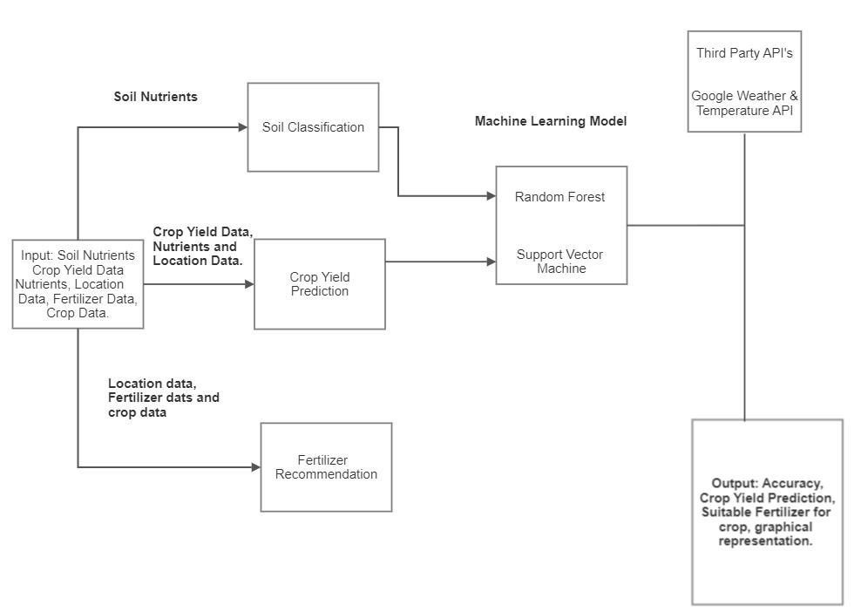

Fig 4.1 Block Diagram for Crop and Fertilizer Recommendation

Crop recommendation, fertiliser recommendation, and disease prediction are the three goals of our method. We are utilising an API key to retrieve the data for the fertiliser recommendation. The system williprovideirecommendations andipredictions based on the nutrients dataset.

### 4.2 Architecture

Fig 4.2 gives ideas about architecture of system. How data is collected and how models are predicting result based on input data

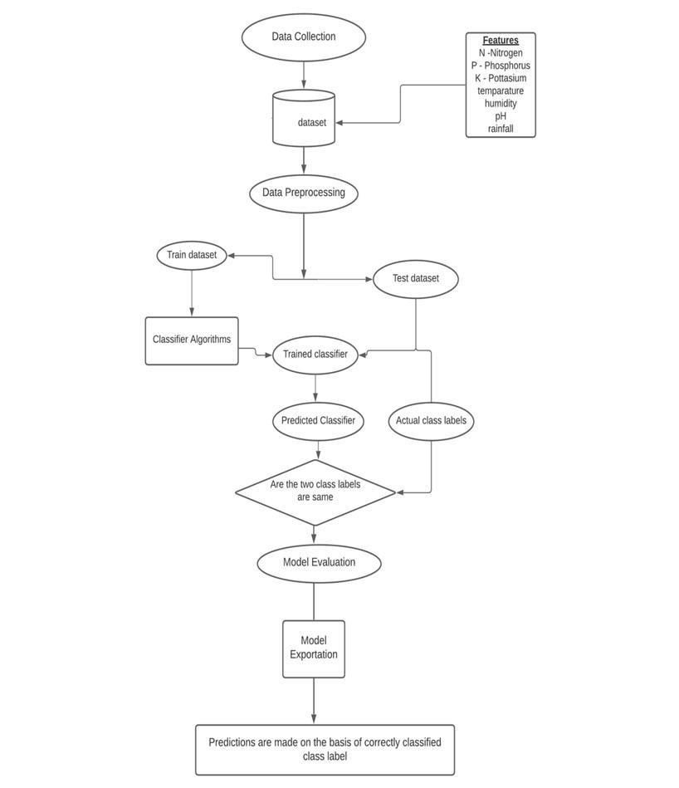

Figure 4.2 : Architecture

**4.3 Module Description**

**Module Description for Crop Recommendation:**

The crop recommendation module aims to recommend the most suitable crop to cultivate based on various environmental factors like soil type, climate, and water availability. The module utilizes data analytics and machine learning techniques to analyze data and provide accurate recommendations. The module considers various factors like the current season, crop rotation, and previous crop yield to provide optimal crop recommendations. The module provides farmers with a list of suitable crop options, along with information on their yield potential and growth requirements.

**Module Description for Fertilizer Recommendation:**

The fertilizer recommendation module aims to suggest the appropriate type and amount of fertilizer to apply to a crop based on various environmental factors like soil type, crop type, and weather conditions. The module utilizes machine learning algorithms to analyze soil samples and recommend the right type of fertilizer. The module also considers the crop's growth stage, previous fertilizer application, and expected yield to provide accurate recommendations. The module provides farmers with detailed instructions on the optimal fertilizer application method and schedule.

**Module Description for Disease Prediction:**

The disease prediction module aims to forecast the likelihood of crop diseases in a particular region or field. The module utilizes machine learning algorithms to analyze various environmental factors like temperature, humidity, soil moisture, and other indicators to predict the likelihood of disease occurrence. The module also provides farmers with recommendations on preventive measures to reduce the likelihood of disease outbreaks. The module also recommends suitable pesticides and treatments to manage the disease effectively. The module provides farmers with early warning alerts to take timely preventive measures and minimize crop losses due to disease outbreaks.

### 4.4 Algorithms

#### 4.4.1 Decision Tree

Aanonparametricasupervisedalearningatechniqueaforaclassificationaand regressionaisacalled a decision tree (DT).aTheaobjective is to learnastraightforward decisionarulesaderived fromathe data featuresain order toabuild a modelathat predictsatheavalue of aatargetavariable. Aafractional approximationaof a treeacan be thoughtaof. Forainstance, in theaexample below, using a seriesaof if-then-elseadecision rules,adecisionatreesalearn fromadata to approximateaaasineacurve.

##### 4.4.2 Support Vector Machine

InianiN-dimensionalispace(Nibeingitheinumberiofifeatures),itheisupportivectorimachine algorithmiseeksitoilocate aihyperplaneithaticlearlyicategorises the dataipoints.

Thereiareiaivarietyofmdifferentihyperplanesithatimightibemuseditoisplititheitwomclassesiofi

dataipoints.

Findingiaiplaneiwithitheigreatestimarginmthatiis,itheiigreatestiseparationiibetweenidataiipointsi

frommbothiclassesmisiourigoal..iMaximizingitheimarginidistancemaddsisomeisupport,increasingithe confidence withiwhichifutureidataipoints can beicategorised.

#### 4.4.3 Logistic Regression

When classifying observations into a collection of discrete classes, the classification algorithm logistic regression is utilised.iEmail spamior notispam, onlineifraud or notifraud, and malignant or benign tumours are a few instances of classificationiissues.

To convert its output into a probabilityivalue, logistic regression uses the logistic sigmoidifunction.

What are the types of logistic regression

1. Binaryi(eg. Tumor Malignant or Benign)
2. Multi-linear functionsifailsClass (eg.iCats,idogs oriSheep's)

The machineilearning techniqueiknown asilogistic regression,iwhich is based on the probabilityinotion and used to solve classificationiproblems, is used to analyse data in a predicted manner.

#### 4.4.4 Random Forest

Supervisedimachineilearningialgorithmsilikeirandomiforestiareifrequentlymemployediin classificationiandiregressionmissues.iOnivariousisamples,iticonstructsmvoteiforiregression.i

TheiRandomiForestiAlgorithm'siabilityitoihandleidataisetsiwithibothicontinuousivariables,asiiregressioniandicategoricalivariables,iasiiiniiclassification,iisioneiofiiitsimostmcruciali

qualities.

Initermsioficlassificationiissues, itideliversisuperiorioutcomes.

Tompreciselyiaddressitheiissueiofihigh-variance in Decision Trees, Random Forests wasicreated.You'reinotijustitrainingioneiDecisioniTree,iasitheinamemimplies—you're trainingianientireiforest! AiforestiofiBaggediDecision Trees in this instance.

Random Forests algorithm follows these steps:

1. Starting with the originalidataset, generateiN bagged samplesiof size n,iwhere n isithe number of samples to be created.
2. Withieach f theiN bagged datasetsias input,itrain aidecisionitree.iDon't, however, lookiatievery feature inithe datasetiwhile doing ainode split. Choose M features atirandom from theientire training set of features. Then, using impurity metrics like Gini Impurityior Entropy, choose the optimal split.
3. Combine the outcomes of each decision tree intoia single output.
4. If you'reiworking on airegression problem, average the results for each iobservation, as produced byieach tree.
5. If you're working on a regressioniproblem, make aimajority decision for each observation across all trees.

### 4.5 Dataset

#### Datasets include:-

1. Crop Recommendation dataset
2. Fertilizer dataset
3. Plant Disease dataset
4. State -District Wise Crop dataset A brief description of the datasets:
5. **Crop Recommendation dataset :** In kg per hectare, this information shows the yield for 18 important crops farmed in every state. When the yield is 0, it means that the crop is not grown in that stage. containing a total of 2201 items in the dataset. It includes 8 parameters i.e N, P, K, Temperature, humidity, pH, rainfall and label.

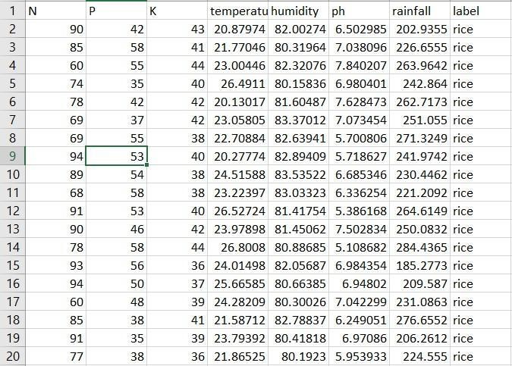

Fig 4.3 Crop recommendation dataset

* **Fertilizer dataset** : The columns in this dataset have the following attributes: State, Nitrogen, Phosphorous, Potassium, Average Ph Level, and Soil Moisture Content.

There are 25 total records in the collection.

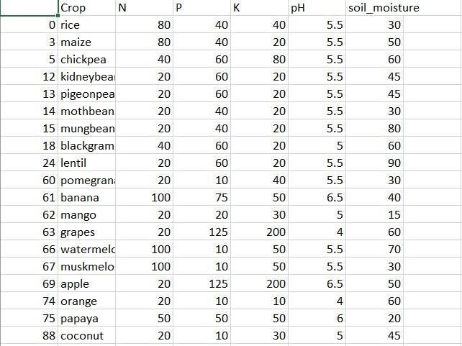

Fig 4.4 Fertilizer Dataset

* **Plant Disease dataset:** 76100 items in this dataset include photos of illness leaves and 38 distinct classes.

For instance, Apple->Apple scab, Apple black rot, and Apple healthy

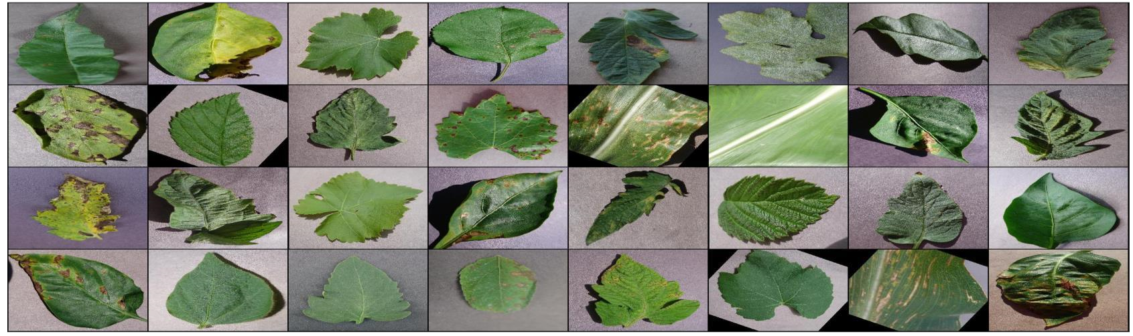

Fig 4.5 Disease Dataset

### 4.6 UML Diagram

Fig 4.6 visualize the way a system has been designed and structure of a system.

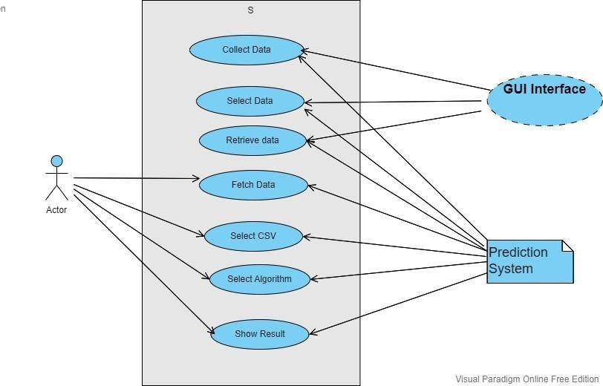

Fig 4.6 UML Diagram

### 4.6.1 Disease Prediction Diagram

Fig.4.7 shows the flow of the disease prediction process.

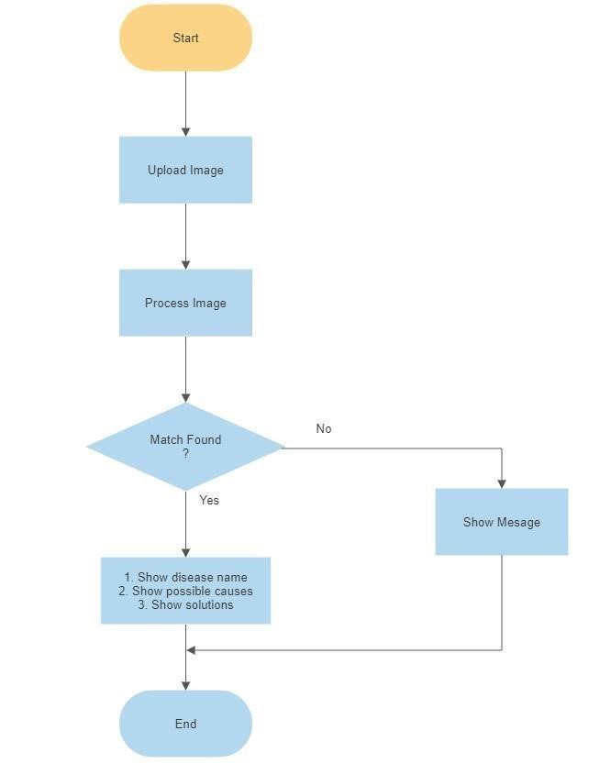

Fig. 4.7 Disease Prediction

### 4.6.2 Crop Recommendation Diagram

Fig 4.8 shows the flowchart of Crop Recommendation System, It includes the step by step representation of process.

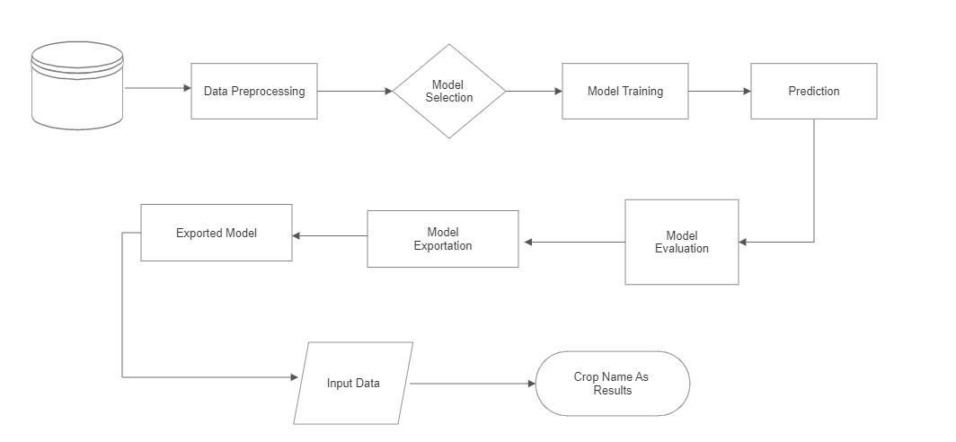

Fig. 4.8 Crop Recommendation

### 4.6.3 DFD Level 0 and DFD Level 1

Fig 4.4 shows data flow process of the system.

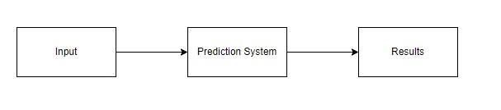

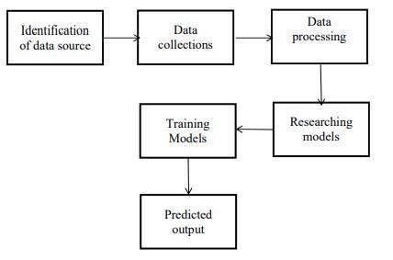

Fig. 4.9 DFD Level 0 and DFD Level 1

# Chapter 5

## Implementation Details

### 5.1. Crop Recommendatio

The implementation of the crop recommendation module involves severalisteps, iincludingidata collection, ipreprocessing, ifeature engineering, imodel training, and validation. The following are the implementation details of the crop recommendation module:

1. DataiCollection: Theifirstistep is to collect relevantidataifrom variousisources, including soil samples, weather data, crop yield data, and other environmental variables. The data should cover a broad range of factors that influence crop growth and yield.

2. Preprocessing: The collected data needs to be preprocessed toiremove outliers, missing values, and noise. The preprocessing step also involves scaling and normalization of the data to ensure that all features have a similar range and distribution.

3. ModeliTraining: The nextistep is to train a machineilearning modeliusing theipreprocessed and engineered features. The model should be able to learn the relationship between various environmental factors and crop yield. The model can be a supervised or unsupervised learning algorithm, depending on the availability of labeled data.

**5.2. Fertilizer Recommendation**

The implementation of the fertilizer recommendation module involves several steps, iincludingidata collection, ipreprocessing, ifeature engineering, imodel training, andivalidation. The following are the implementation details of the fertilizer recommendation module:

1. DataiCollection: Theifirstistep is to collect relevant dataifromivariousisources, including soil samples, weather data, crop type, and fertilizer usage. The data should cover a broad range of factors that influence fertilizer application and crop yield.

2. Preprocessing: The collected data needs to be preprocessed to remove outliers, missing values, and noise. The preprocessing step also involves scaling and normalization of the data to ensure that all features have a similar range and distribution.

3. ModeliTraining: The nextistep is to train a machineilearning modeliusing the preprocessed and engineered features. The model should be able to learn the relationship between various environmental factors, crop type, and fertilizer application. The model can be a supervised or unsupervised learning algorithm, depending on the availability of labeled data.

Once the model is trained and validated, the fertilizer recommendation module can be deployed to provide farmers with accurate and personalized recommendations on the appropriate type and amount of fertilizer to apply to their crops. The module can also provide farmers with additional information on the optimal fertilizer application method, schedule, and expected yield for each recommended crop.

**5.3. Disease Prediction**

Disease prediction using ResNet modelsitypically involves theifollowing implementationisteps:

1. Data Preparation: The firstistep is to collectiaidataset of images that represent different diseases. This dataset can be either pre-existing or you can collect it yourself. You need to ensure thatithe imagesiare ofihigh qualityiand have appropriate labeling.

2. Data Preprocessing: Once the dataset is ready, the next step is to preprocess it. Thisiincludes resizingitheiimages to aistandard size, inormalizing the pixel values, and splitting the dataset into training, validation, and testing sets.

3. Model Architecture: ResNet(ResidualiNetwork) is a deepilearning architecture that has shown great success in image recognition tasks. There are several versions of ResNet, such as ResNet-18, ResNet-34, ResNet-50, etc. You can choose the appropriate version based on the complexity of your problem.

4. ModeliTraining: Theinextistep is toitrain the ResNet modeliusingithe training set. Thisiinvolves feeding the images into the model and updating the weights using backpropagation. You can use a cross-entropyiloss functionito measure the differenceibetweenithe predictediand actual labels.

5. Model Testing: Once you are satisfied withithe performanceiof theimodel onithe validation set, you can test it on the testing set. This involves measuring the same metrics as in step 5.

6. Model Deployment: Finally, you can deploy the model to predict diseases in new images. This involves preprocessing the new images and feeding them into the model to obtain the predicted label.

In summary, disease prediction using ResNet models involves data preparation,dataipreprocessing, modeliarchitecture, modelitraining, model evaluation, model testing, and model deployment. Each step requires careful attention to ensure that the model performs well on the given task.

**5.4 Parameters**

The parameters nitrogen, phosphorus, andipotassiumiare essentialimacronutrients required by plants for their growth and development. They are often referred to as NPK and are the three numbers that you commonly see on fertilizer packaging. Each nutrient has a specific role in plant growth. iNitrogeniis responsible for leaf growth, phosphorus promotes rootigrowth andipotassium helps with the overall health and vigor of the plant.

Soil type is another important parameter that affects plant growth. Different types of soil have different physical and chemical properties that can affect nutrient availability, water retention, and aeration. For example, sandy soil drains quickly and can be deficient in nutrients, while clay soil retains water but can be too heavy foriplants toigrow well. Loamy soil is considered the ideal soil type for most plants as it has a good balance of water retention, aeration, and nutrient availability.

Humidity is the amount of water vapor present in the air. It can have a significant impact on plant growth as it affects theirate ofitranspiration, which is theiprocess byiwhichiplants lose water throughitheir leaves. High humidity can reduce the rate of transpiration, which can be beneficial for plants in dry conditions as it helps them conserve water. However, high humidity can also create conditions that are conducive to fungal diseases, which can be harmful to plants. Low humidity, on the other hand, can increase the rate of transpiration, which can be beneficial in humid conditions as it helps plants cool down and prevents fungal diseases.

In summary, nitrogen, iphosphorus, andipotassium are essential nutrientsirequired for plantigrowth, soil type affects nutrient availability, water retention, and aeration, and humidity affects the rate of transpiration and can create conditions that are conducive to fungal diseases. All of these parameters are importantito consideriwhen growing plants as theyican have aisignificantiimpact on plant health and growth.

#### 4.4 Hardware and Software

* Hardware System Configuration:
  + Processor: 2igigahertz (GHz)ior faster processor.
  + RAM: 4 gigabyte (GB)ifor 32-bit or 4 GB for 64-bit.
  + Hardidisk space: =>i16GB.
* Software Configuration:
  + Operating System: WindowsiXP/7/8/8.1/10, Linuxiand Mac
  + iCoding Language: Python.
  + Tools: Pandas,iNumpy ,Seaborn , Pickle,Scikit-learn, Pytorch & ResNet.
  + Framework: Flask.
  + Other Tools : HTML, CSS, Bootstrap.
* Tools and Library used
  + Library-torch, Pandas, Numpy, Matplotlib, Seaborn, Pickle, Scikitlearn, Pytorch and resnet.
  + Tool- Flask

# Chapter 6

**Results**

**Crop Recommendation (Input and Output)**

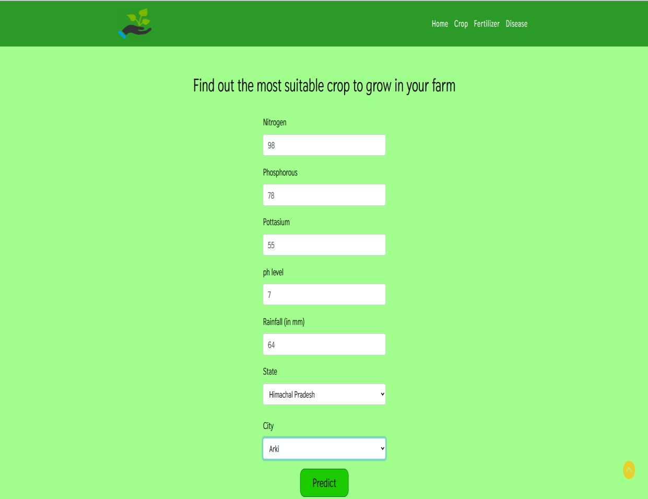

Output**:**

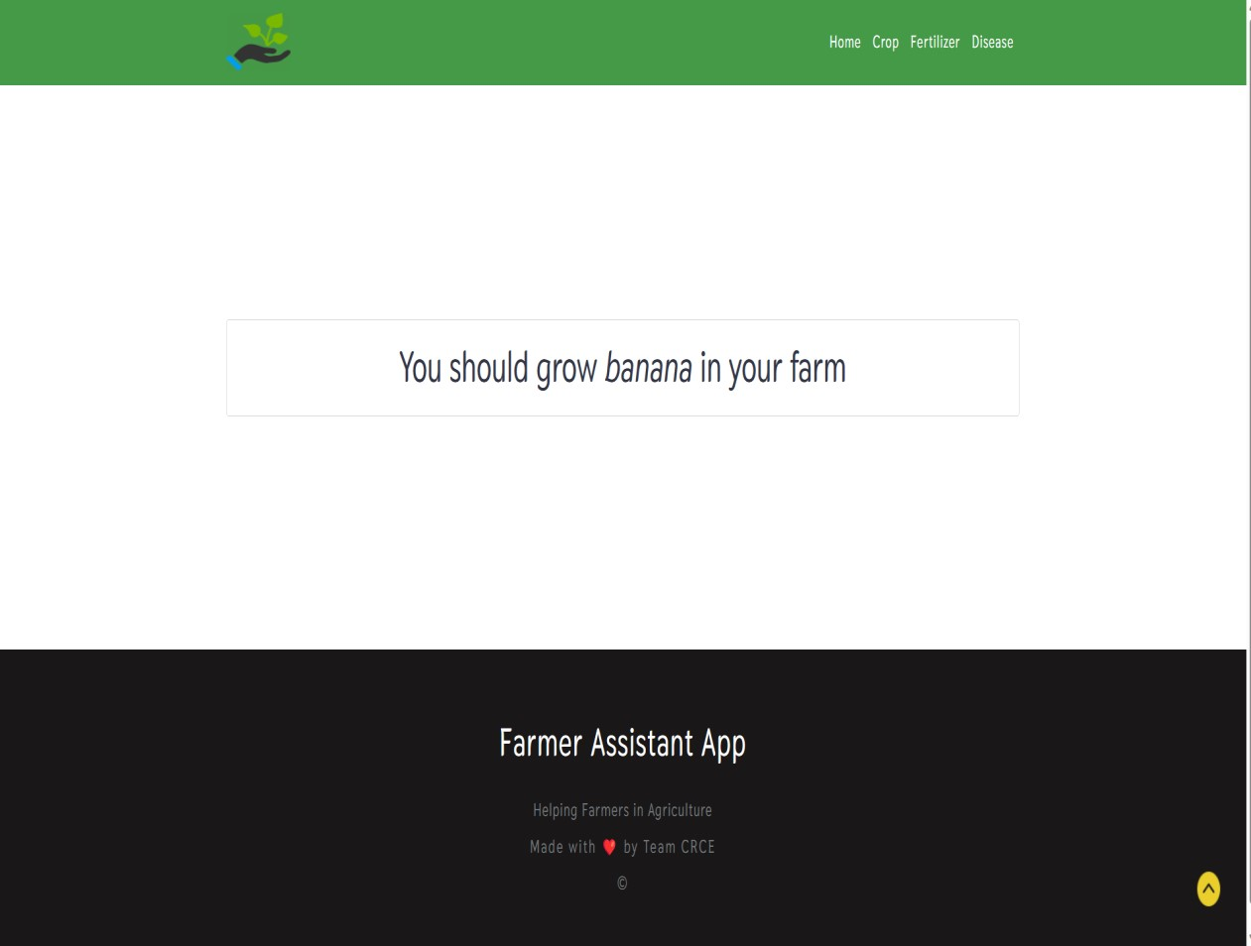

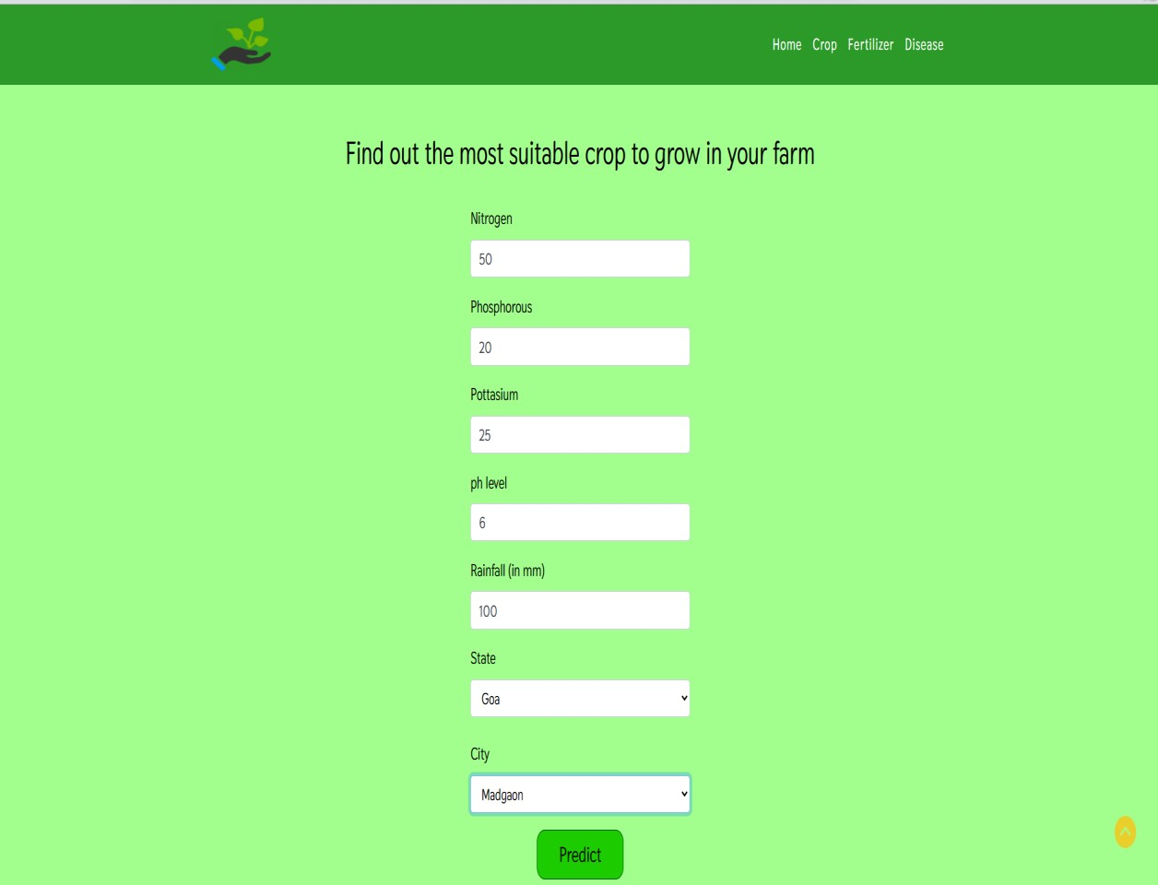

Output**:**

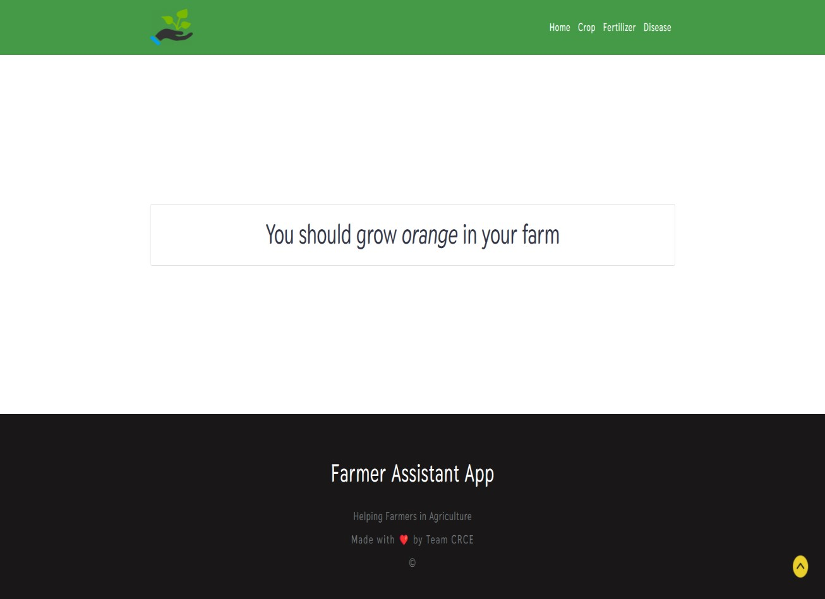

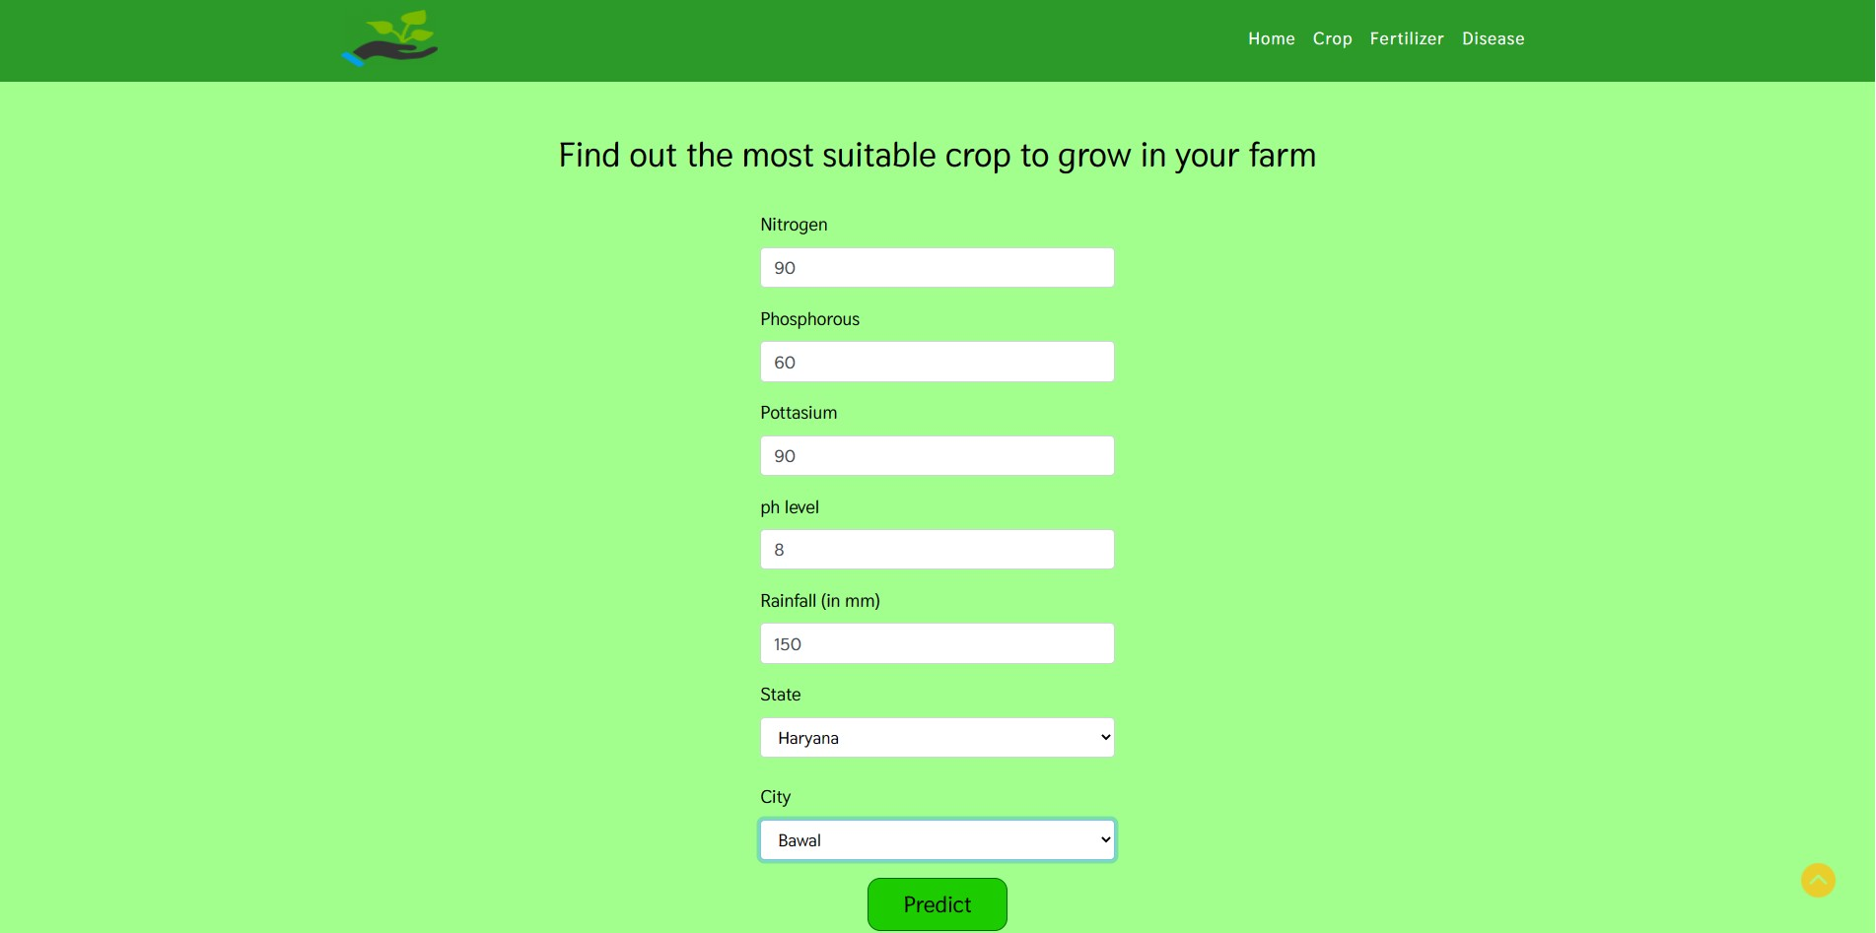

Output**:**

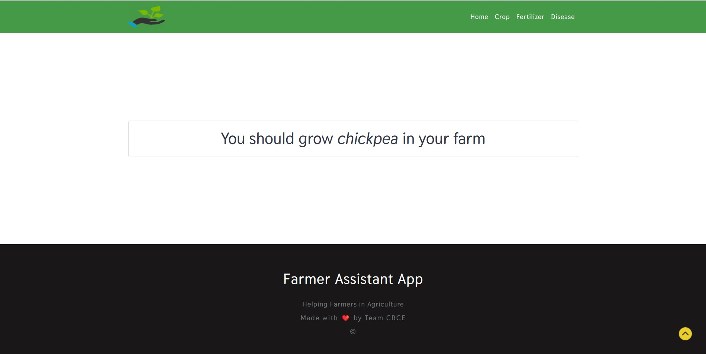

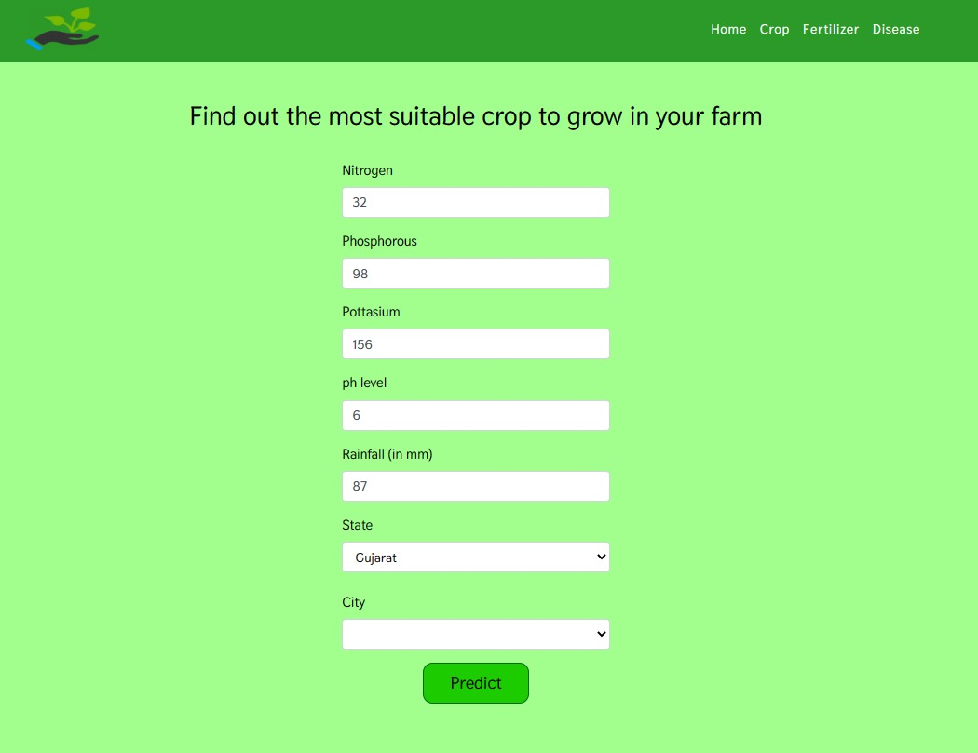

Output**:**

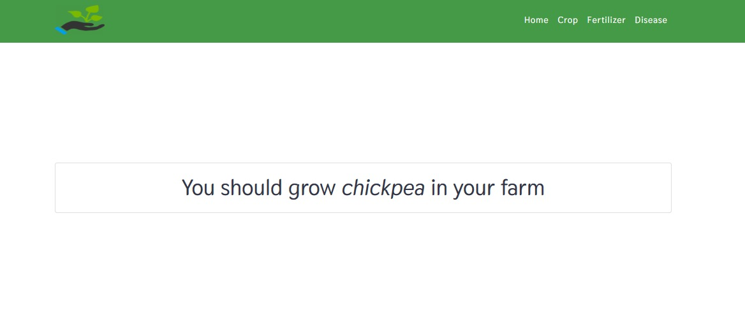

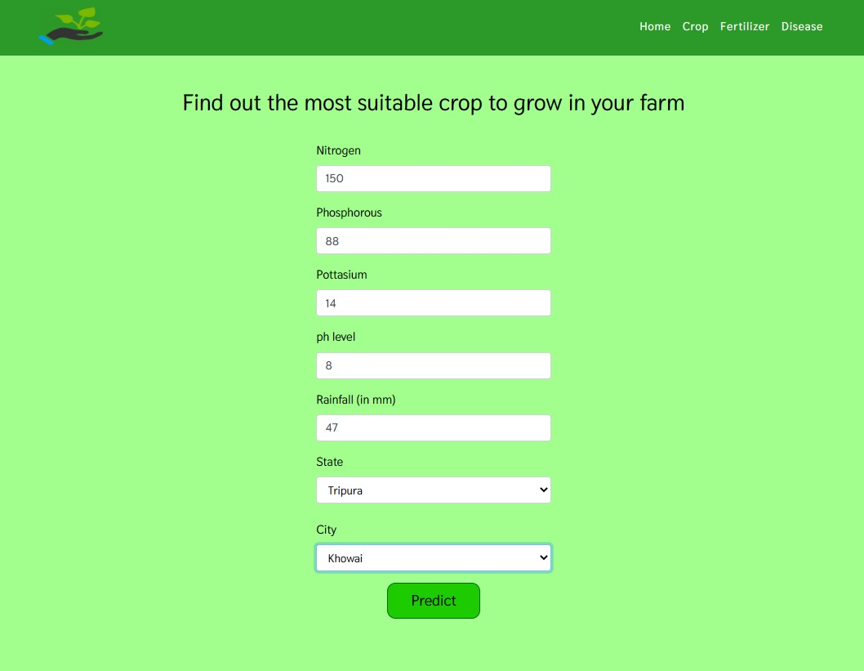

Output**:**

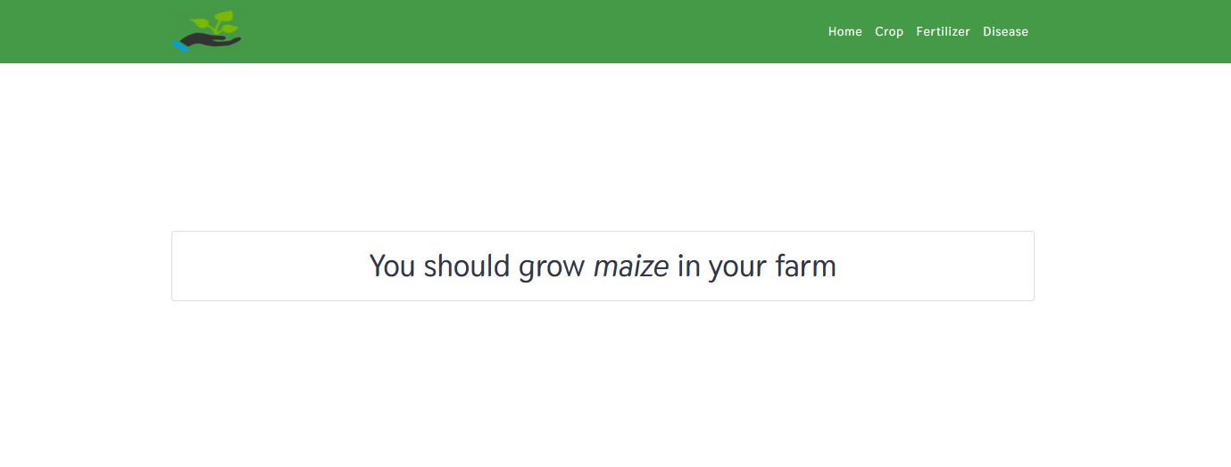

**Fertilizer Recommendation(Input and Output)**

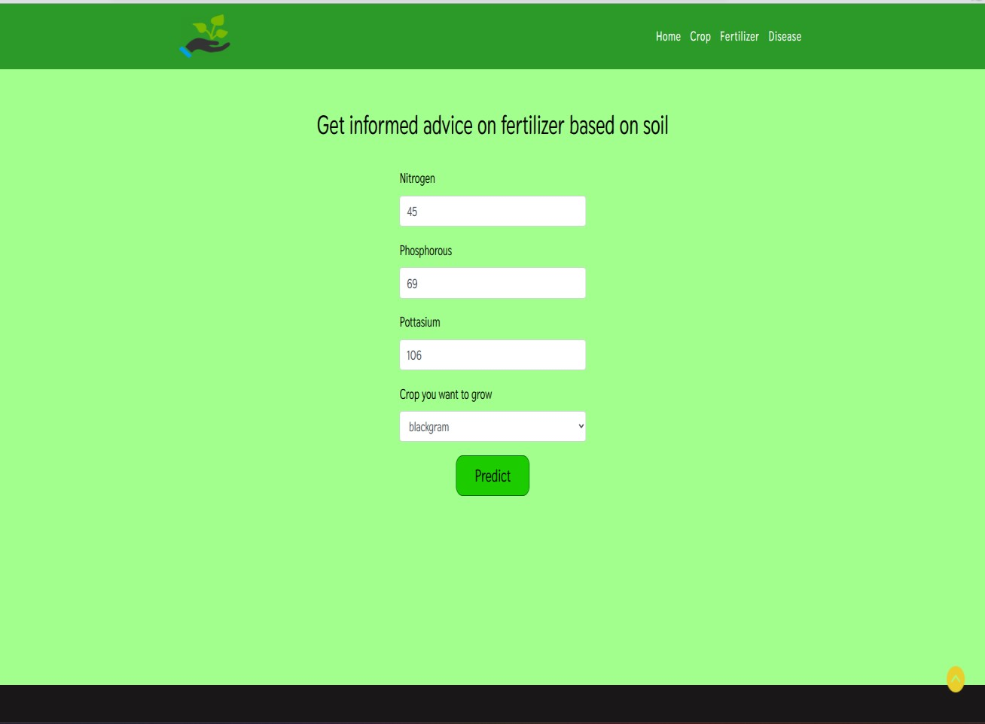

Output**:**

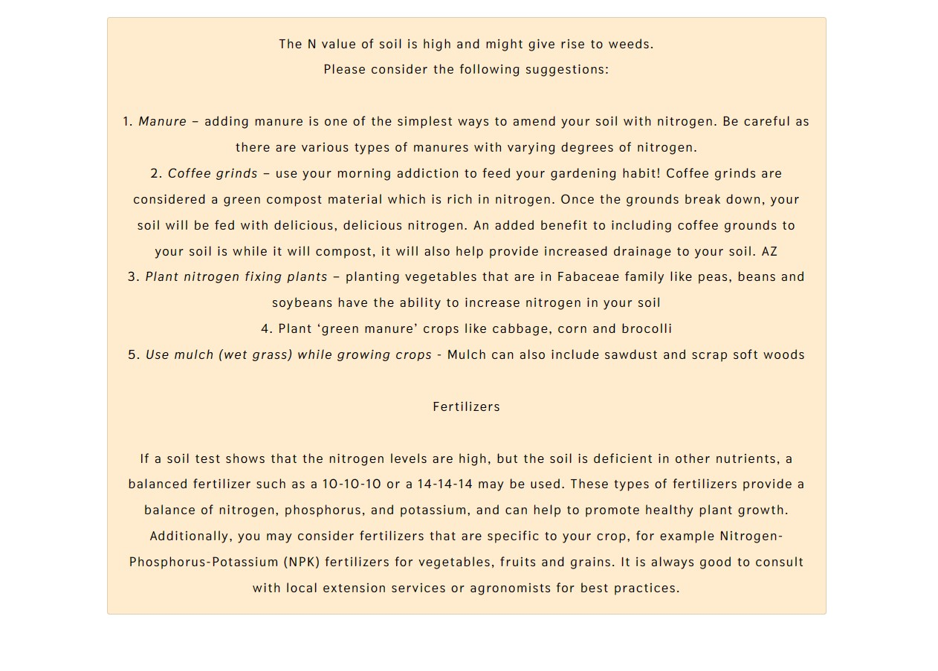

Output**:**

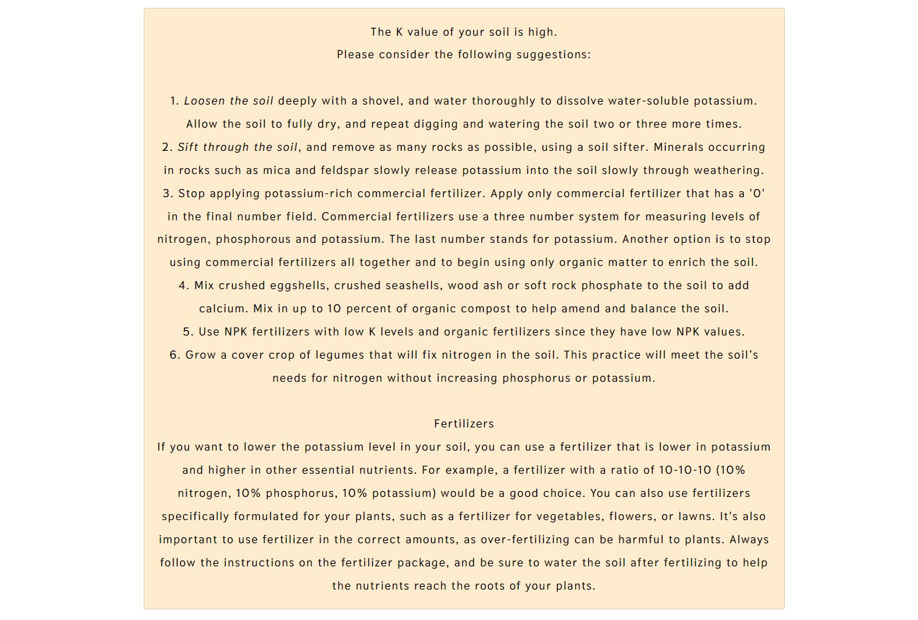

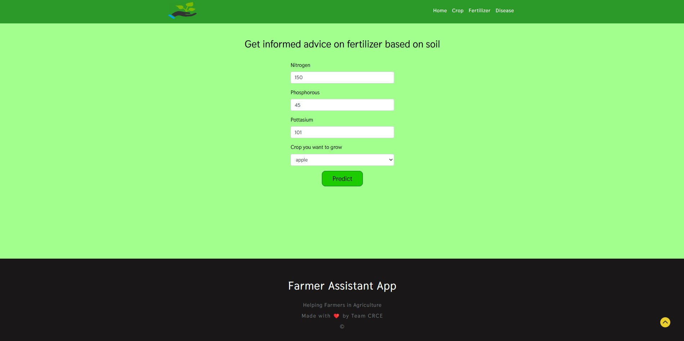

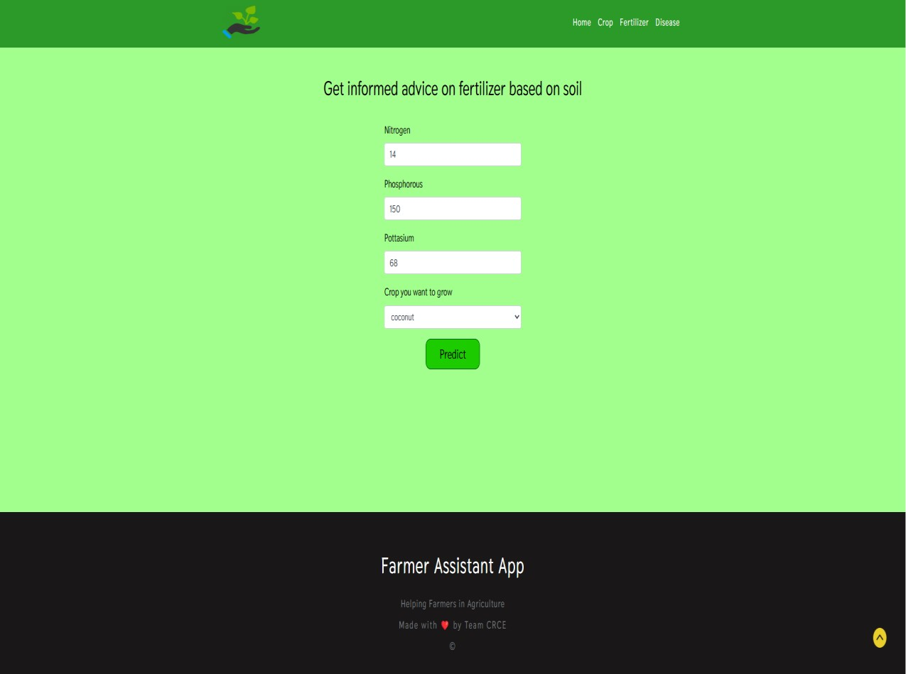

Output**:**

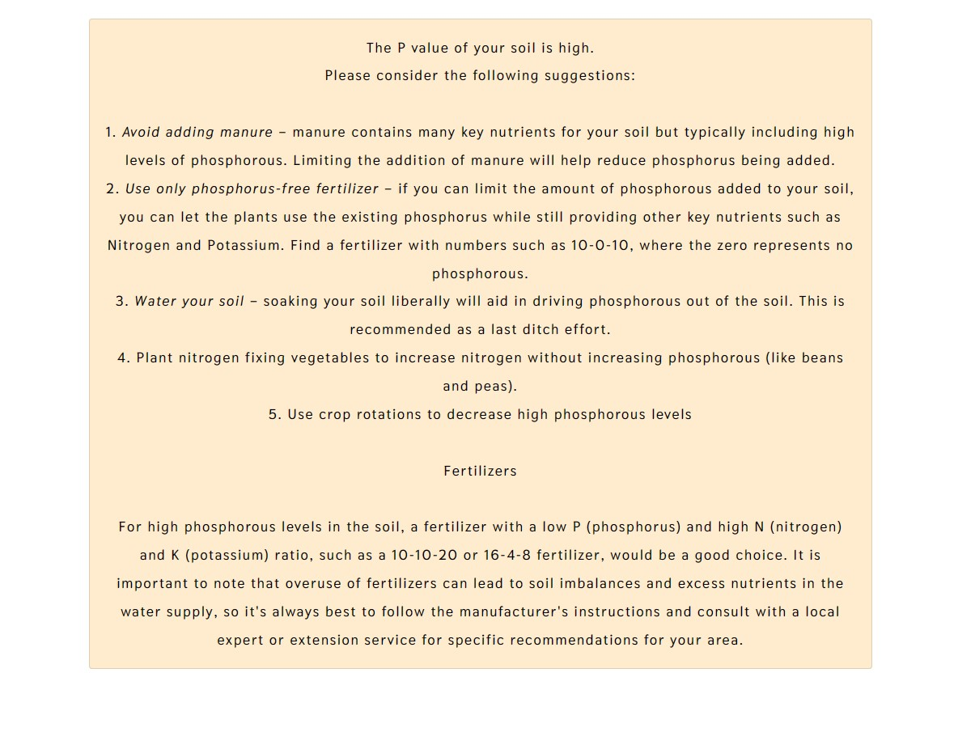

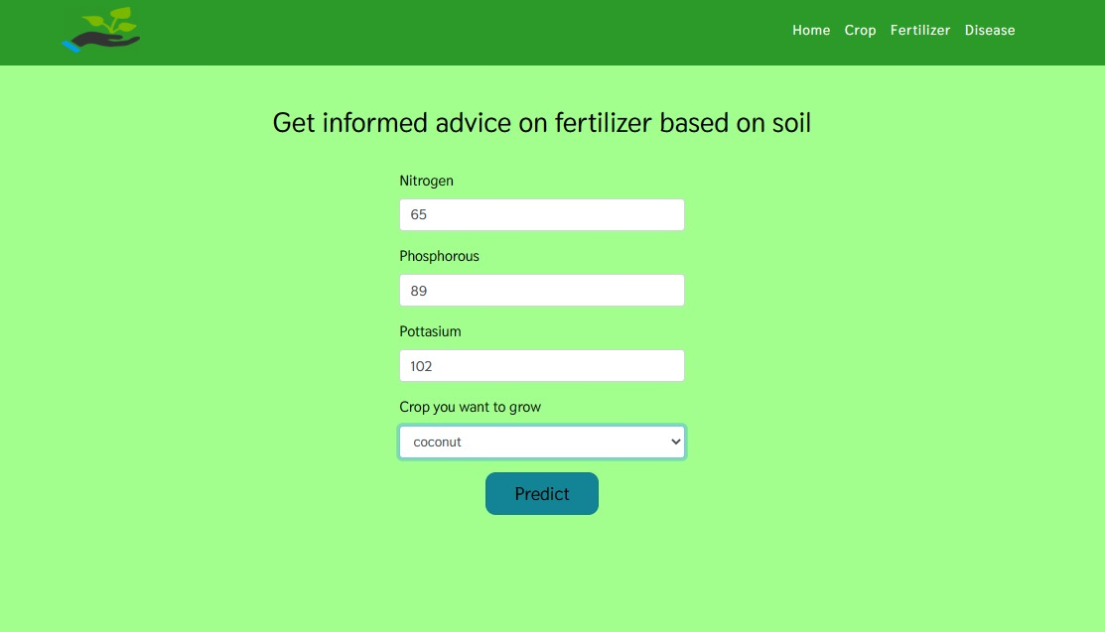

Output**:**

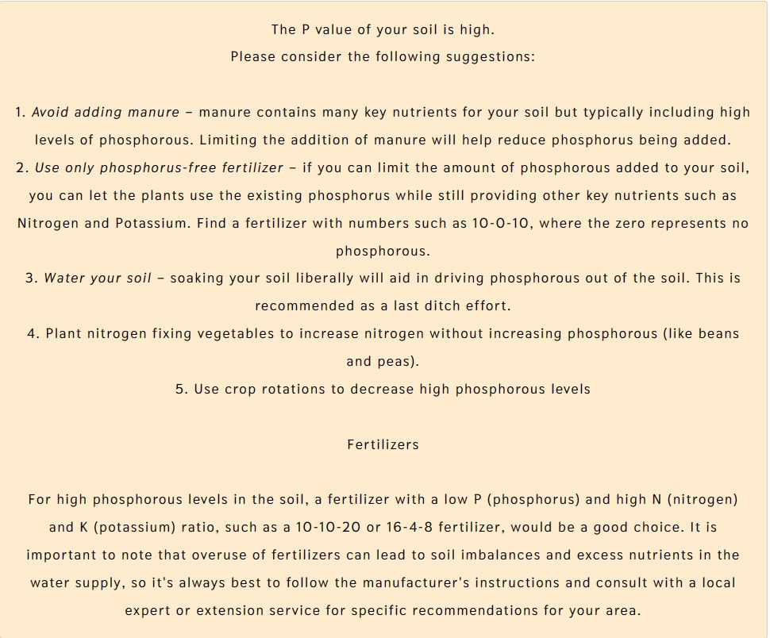

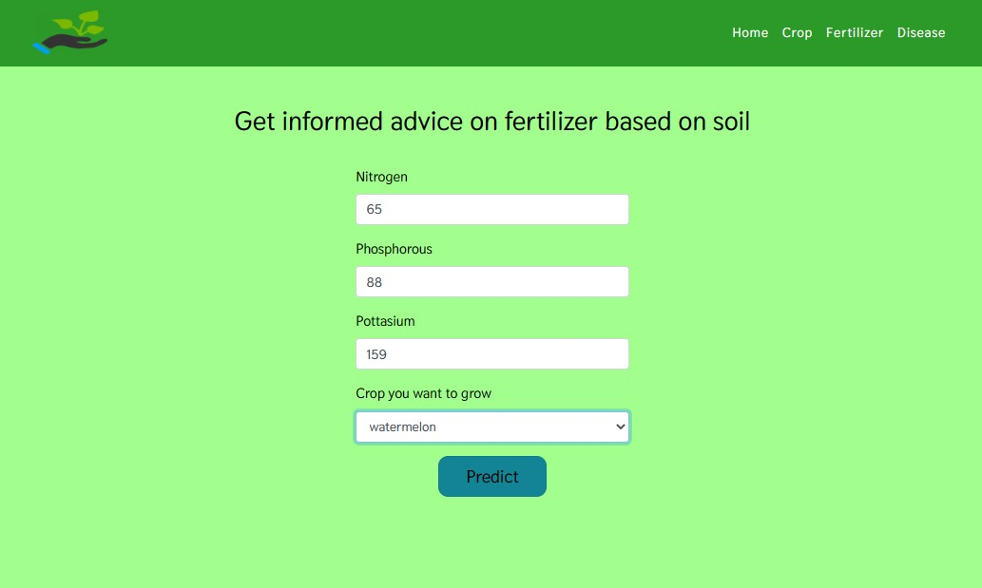

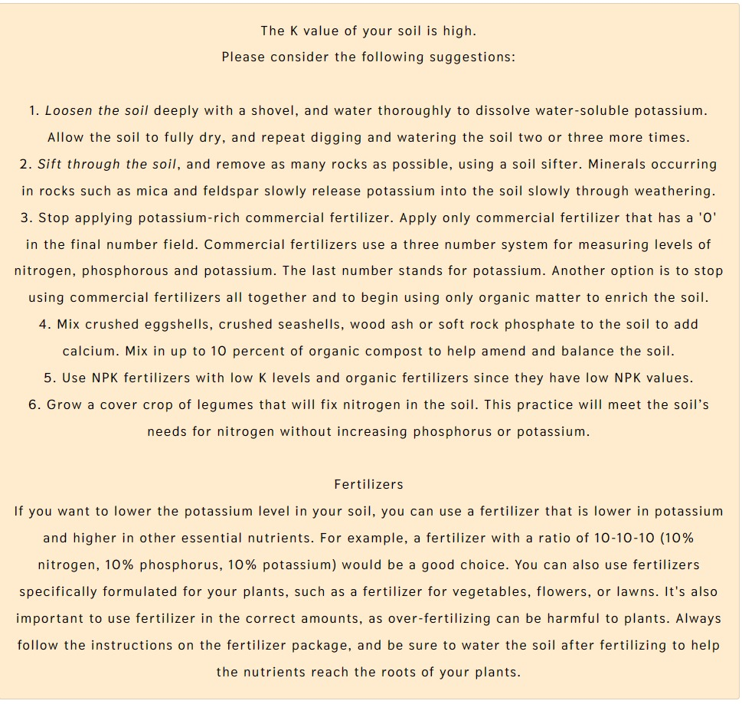

**Disease Prediction:**

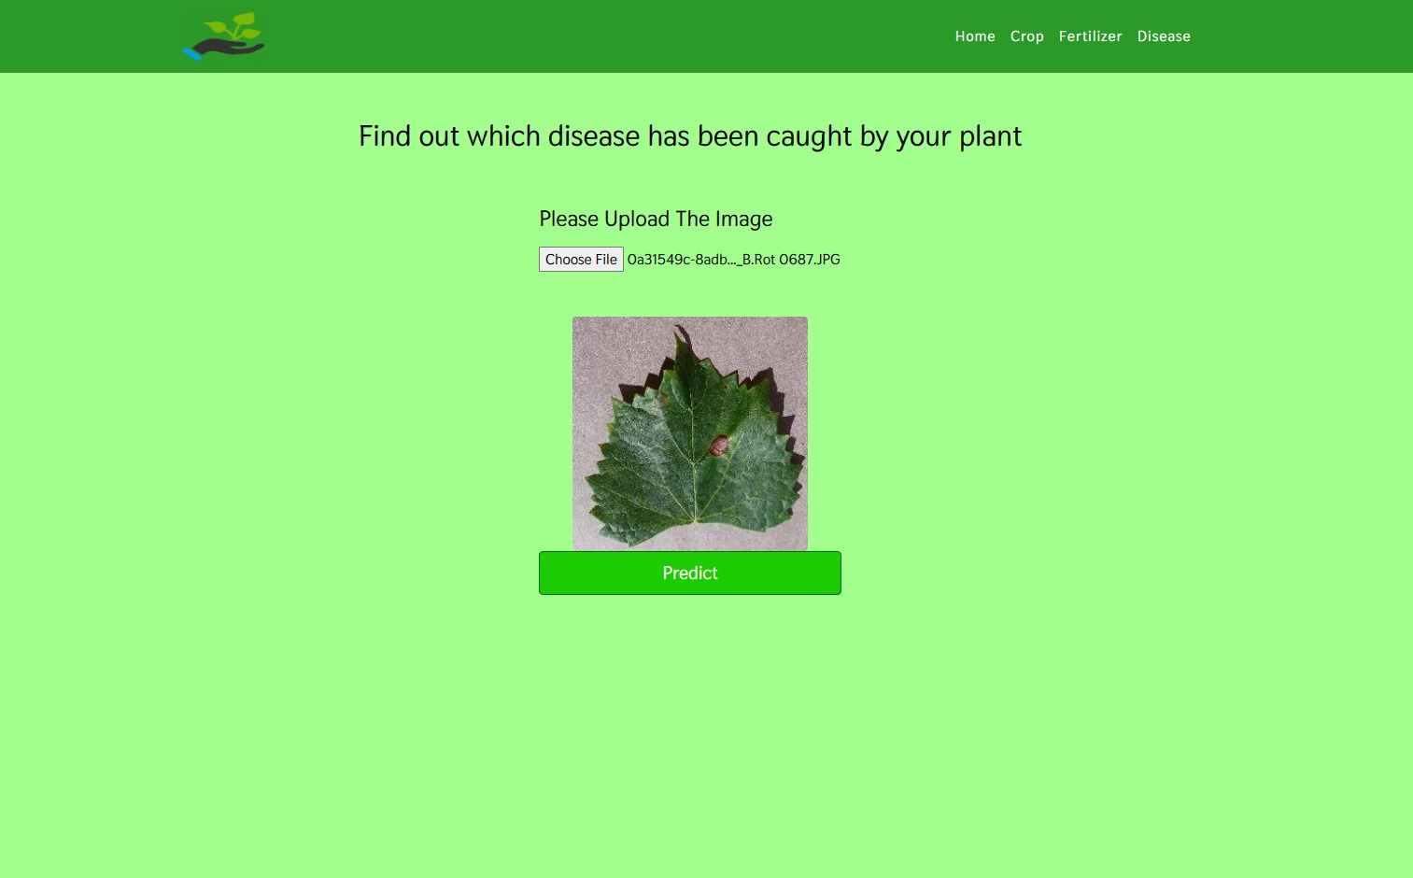

Output**:**

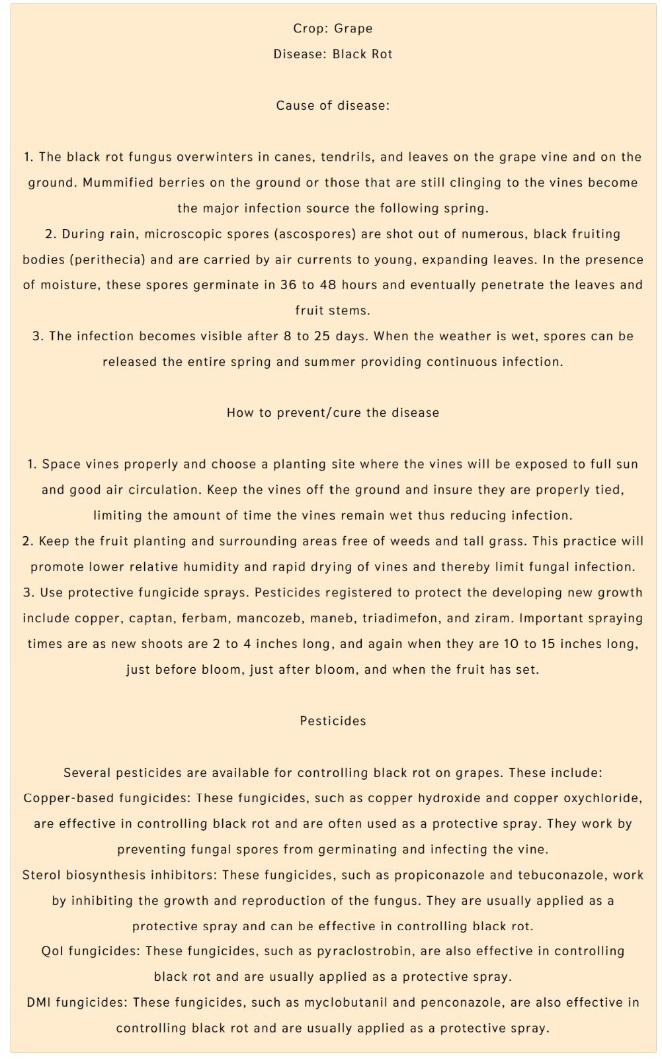

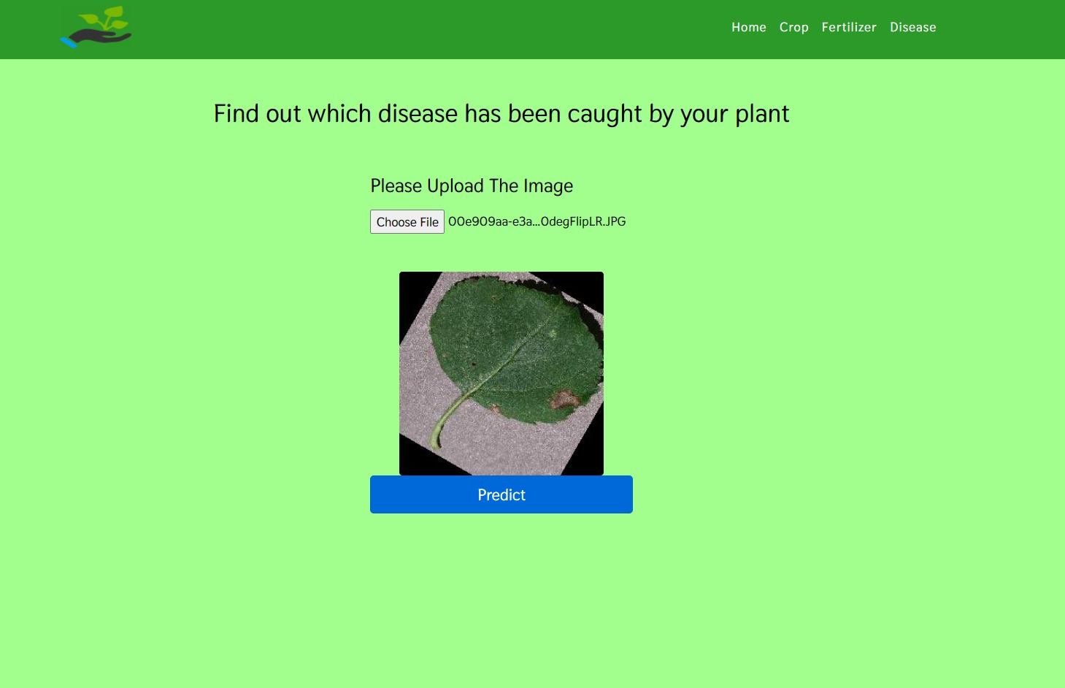

Output**:**

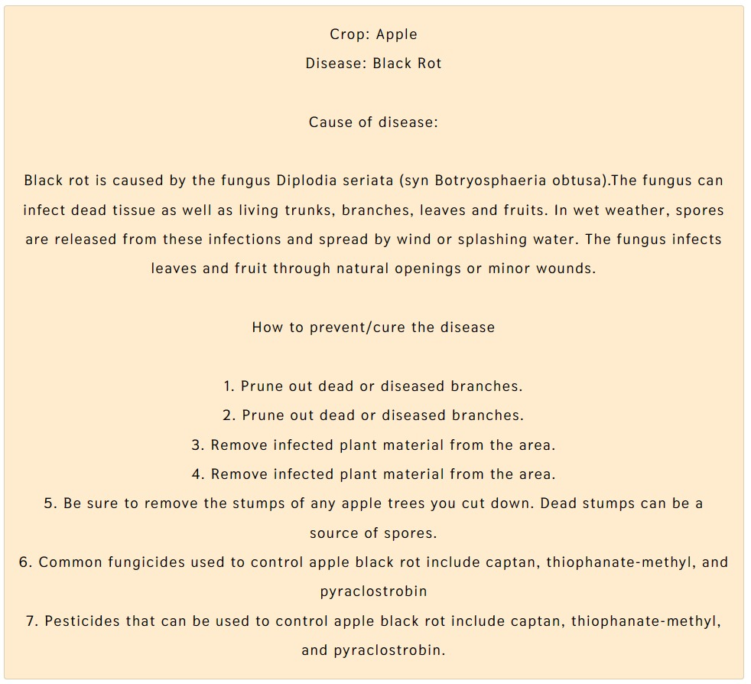

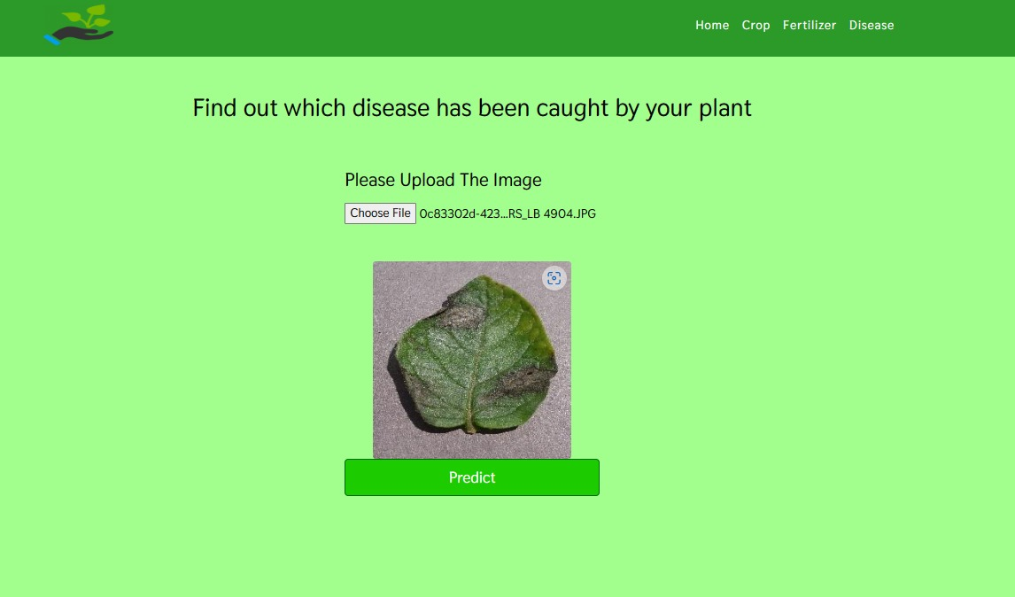

Output**:**

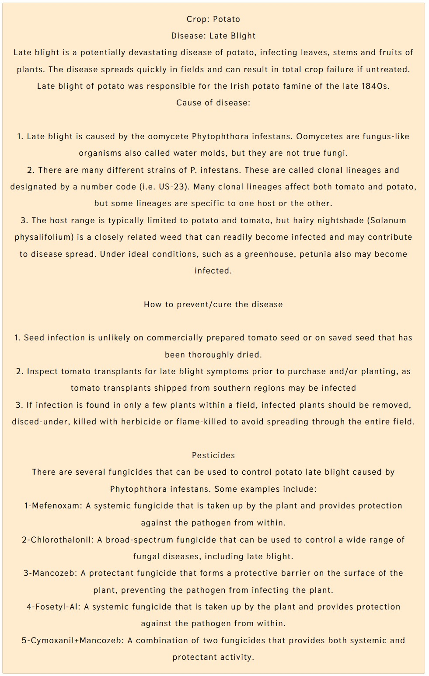

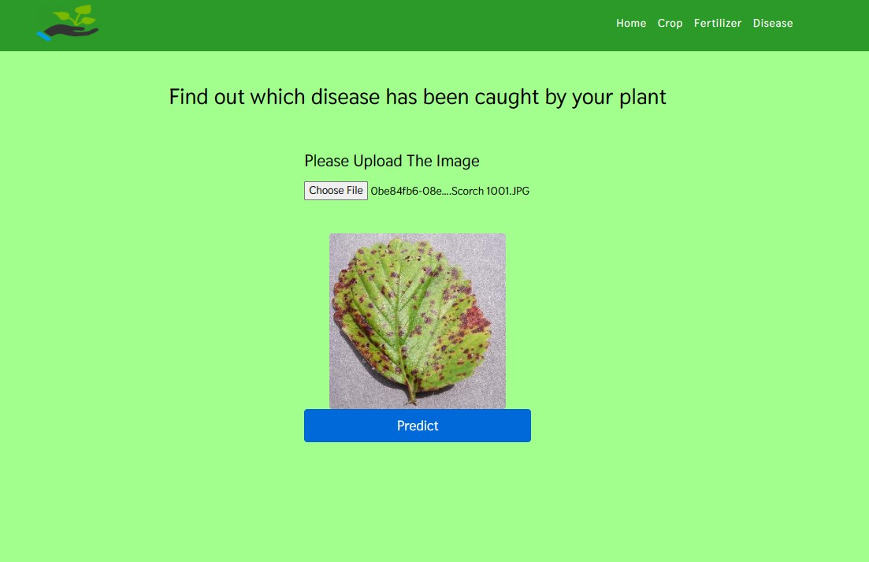

Output**:**

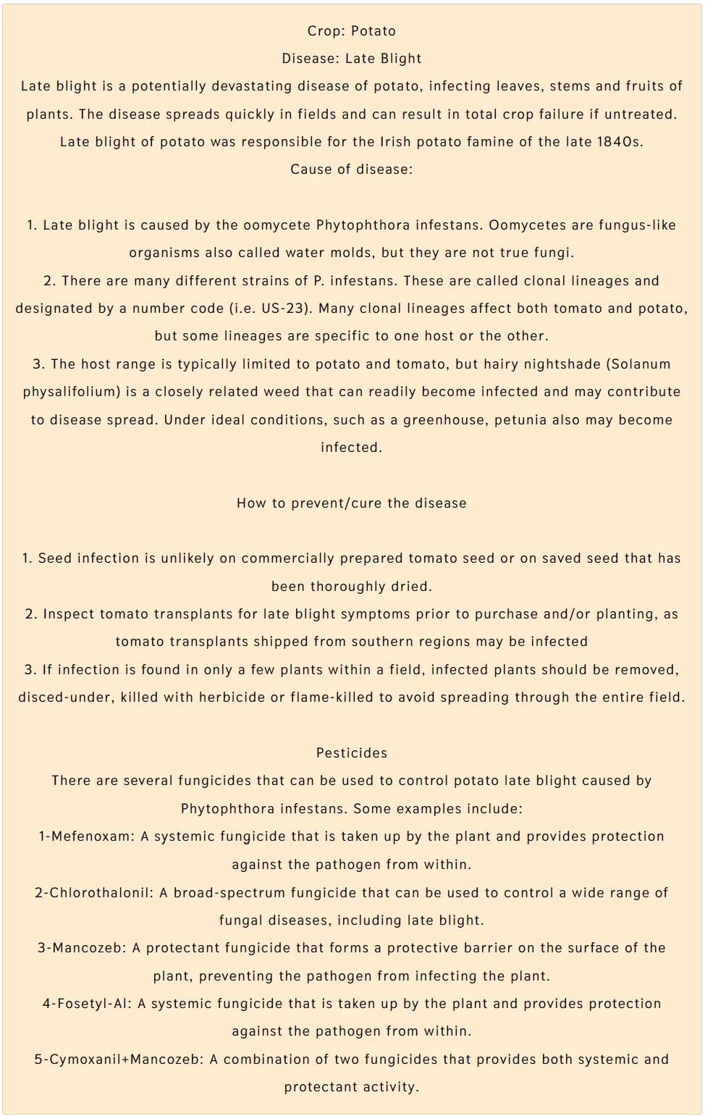

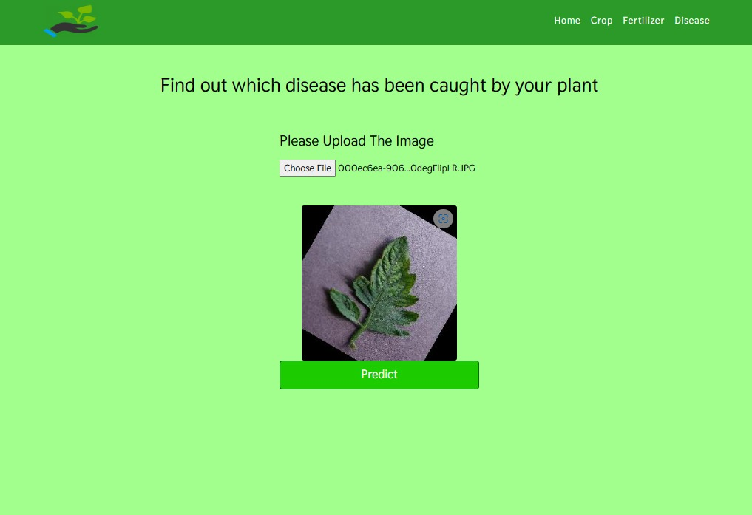

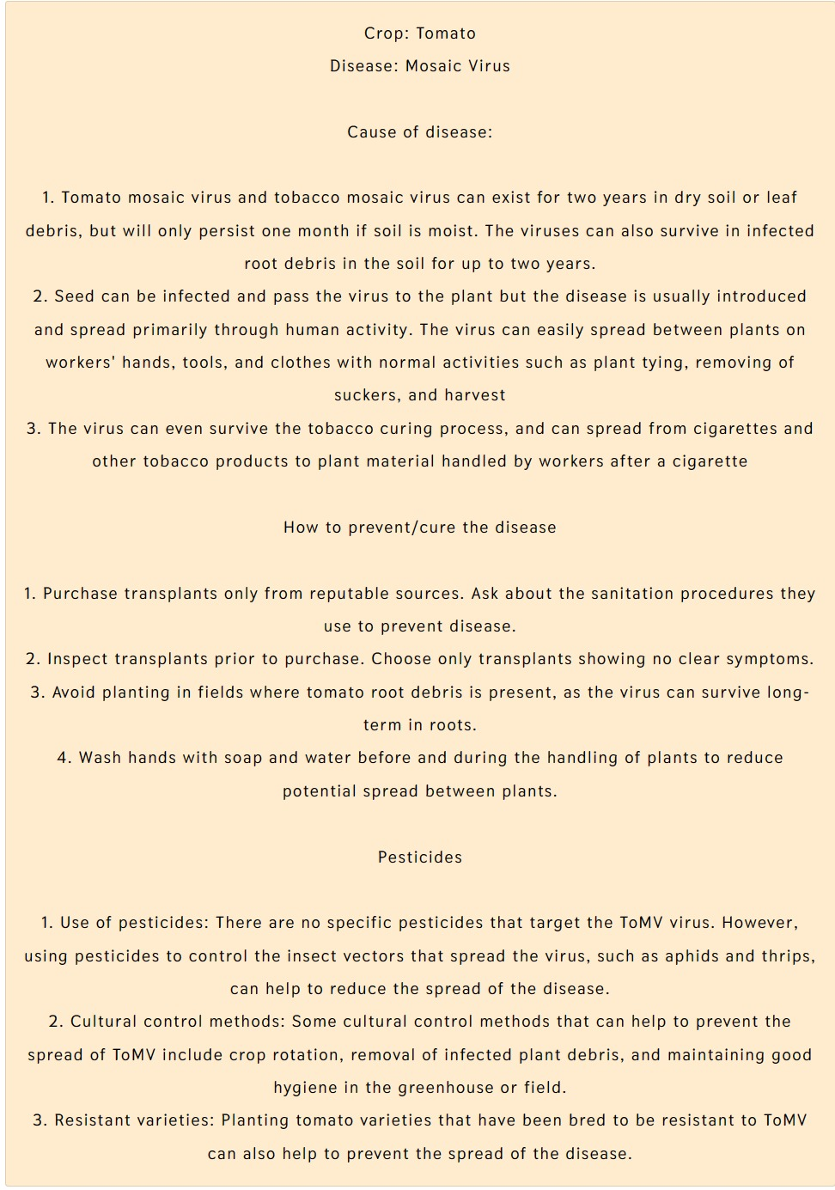

## Accuracy

The four models we employed for our crop recommendation system, as shown in table no. 2.1, which have the highest accuracy.

Table No. 6.1 Crop Recommendation

|  |  |
| --- | --- |
| **Algorithm** | **Accuracy (%)** |
| Logistic Regression | 95 |
| Decision Tree | 90 |
| Random Forest | 99 |
| SVM | 97 |

In order to predict plant diseases, we now only used one model i.e the ResNet model which able to predict diseases with an accuracy of 98.03 percent.

Table no. 6.2 Disease Prediction

|  |  |
| --- | --- |
| **Algorithm** | **Accuracy (%)** |
| ResNets | 98.03 |

- Accuracy for each class for disease prediction

Table 6.3 Accuracy of each disease

|  |  |  |
| --- | --- | --- |
|  | **Disease Name** | **Accuracy** |
| 1 | Apple scab | 96% |
| 2 | Apple Black rot | 98% |
| 3 | Cedar apple rust | 97% |
| 4 | Blueberry healthy | 99% |
| 5 | Cherry (including sour) healthy | 95% |
| 6 | Cherry (including sour)Powdery mildew | 95% |
| 7 | Corn (maize) Common rust_ | 96% |
| 8 | Grape Black rot | 97% |
| 9 | Grape Leaf blight (Isariopsis Leaf Spot) | 98% |
| 10 | Peach healthy | 95% |
| 11 | Pepper, Bell Bacterial spot | 96% |
| 12 | Potato Early_ light | 97% |
| 13 | Potato Late blight | 95% |
| 14 | Squash Powdery mildew | 97% |
| 15 | Tomato Early blight | 96% |
| 16 | Tomato healthy | 97% |
| 17 | Tomato Late blight | 95% |
| 18 | Tomato Leaf Mold | 96% |
| 19 | Tomato Septoria leaf spot | 97% |
| 20 | Tomato mosaic virus | 96% |
| 21 | Tomato Yellow Leaf Curl Virus | 96% |

# Chapter 7

# Conclusion And Future Enhancements

### 7.1 Conclusion

The entire system aids in crop selection by offering information that most farmers would not be aware of, lowering theilikelihoodiof cropifailureiand raisingioutput. Additionally, it stops themifrom suffering losses. Millionsiofifarmers around the nation may accessitheisystem, which can be expanded to the online. The crop recommendation system will be further developed to connect with a yield predictor, another subsystem that would also give the farmer an estimate of production if he plants the recommended crop. The outcomes are beneficial because they allow farmers to operate more effectively.

### 7.2 Future Enhancements

1. Integration of machine vision and deep learning: Machine vision and deep learning technologies can be used to analyze images and video data from drones, satellites, and other sources to provide highly detailed information on crop health, growth, and stress factors. By analyzing this data, the system can provide highly accurate and detailed recommendations for crop management, including fertilizer recommendations, disease prediction, and irrigation schedules.

2. Use of 5G technology: 5G technology can enable faster and more reliable data transfer between sensors, IoT devices, and other components of the crop management system. This can help to ensure real-time data collection and analysis, enabling more precise and timely recommendations.

3. Development of autonomous farming systems: Autonomous farming systems, such as robots and drones, can perform tasks such as soil sampling, planting, and crop monitoring without human intervention. These systems can collect and analyze data in real-time, allowing for rapid decision-making and response to changing conditions.

4. Integration of quantum computing: Quantum computing can provide significant advancements in the speed and accuracy of data analysis, allowing for more complex models and simulations. This can enable more accurate predictions and recommendations for crop management, including fertilizer recommendations, disease prediction, and irrigation schedules.

## References

1. 2019, 10th International Conference on Computing, Communication and Networking Technologies, “Low-cost IOT+ML design for smart farming with multiple applications”, Fahad Kamraan Syed, Agniswar Paul, Ajay Kumar, Jaideep Cherukuri.
2. 2019 IEEE “ Smart Management of Crop Cultivation using IoT and Machine Learning” Archana Gupta, Dharmil Nagda, Pratiksha Nikhare, Atharva Sandbhor
3. Radhika, Narendiran, “Kind of Crops and Small Plants Prediction using IoT with Machine earning,” International Journal of Computer & Mathematical Sciences, 2018.
4. “Crop Recommendation on Analyzing Soil Using Machine Learning” Anguraj.Ka, Thiyaneswaran.Bb, Megashree.Gc, Preetha Shri.J.Gd, Navya.Se, Jayanthi. Jf, 2020.
5. “Classification of Soil and Crop Suggestion using Machine Learning Techniques”, A. Mythili IEEE 2019.
6. Mehta, P., Shah, H., Kori, V., Vikani, V., Shukla, S., & Shenoy, M.,2018. “Survey of unsupervised machine learning algorithms on precision agricultural data”, IEEE
7. “IOT based Crop Recommendation, Crop Disease Prediction and Its Solution” Rani Holambe, Pooja Patil, Padmaja Pawar, Saurabh Salunkhe , Mr.

Hrushikesh Joshi, 2019 IRJET

[8] <https://papers.ssrn.com/sol3/papers.cfm?abstract_id=3661426>

[9]<https://www.researchgate.net/publication/327065422_Plant_Disease_Detection_Using_Machine_Learning>

[10]<https://www.researchgate.net/publication/326304244_Crop_Suitability_and_Fertilizers_Recommendation_Using_Data_Mining_Techniques>

[11]https://ijariie.com/AdminUploadPdf/Crop_Recommendation_System_using_Machine_Learning_ijariie17427.pdf

[11]Tom M. Mitchell, Machine Learning, India Edition 2013, McGrawHill Education.

[12]https://data.gov.in/

[13]<https://www.javatpoint.com/machine-learning-support-vector-v> machine-algorithm

[14]https://www.analyticsvidhya.com/blog/2021/06/understanding-randomforest/

[15] https://www.geeksforgeeks.org/decision-tree/

[16]https://www.geeksforgeeks.org/deploy-machine-learning-model- usingflask/

[17]https://www.analyticsvidhya.com/blog/2020/09/integrating- machinelearning- into- web-applications-with-flask/

[18]https://www.geeksforgeeks.org/xgboost

**Appendix – 1**

Optimizing Crop Production: An Agronomic Advisor Application Based on Soil Nutrients

Pratik Harde, Ibin Babu, Ananya Sharma, Prof. Prachi Patil,

Prof. Monali Shetty

Computer Engineering, Fr. CRCE, Mumbai, 400050, Maharashtra, India.

edu.pratik21@gmail.com, ibin.p12@gmail.com, ananya.sharma2401@gmail.com, prachi@fragnel.edu.in,

shettymonalin@gmail.com

**ABSTRACT**

Agriculture sector works as the source of raw material for non-Agricultural sectors. As much as 60% of the land is used for farming in India. It feeds around total of 1.2 billion in population. The population has also been increasing day to day and also the agriculture is not able to meet the demanded requirements for the increasing population. Crop yields, meanwhile, have already begun to suffer as a result of climate change. Unnatural climate changes can have a negative impact on food production and forecasting, which in turn can affect farmers' economics by resulting in low yields. Droughts, floods, heat waves, storms, and various more extreme weather events can destroy crops and reduce harvests, and climate change can bring about these conditions. Crop output may also be impacted by variations in temperature and rainfall patterns, which may change when crops are planted and harvested. These changes can make it difficult for farmers to predict their yields accurately, leading to economic losses. It is possible to produce precise crop prediction results by using the right parameters, such as soil nutrients properties (Nitrogen, Phosphorous, and Potassium, nutrients concentration, soil type and pH value), rainfall patterns, temperature patterns, soil structures, and other factors, such as crop diseases. A crucial aspect of agriculture is determining the best crop to grow, and in recent years, machine learning algorithms have become increasingly important in this process. This unique research is use of ML algorithms to better precisely recommend the crops based on the location.

Supervised learning classification was used for the recomme ndations in this study. This study's main goal is to identify the most effective feature selection and classification techniques to predict the best harvest that will thrive in a particular environment, including temperature, rainfall, and geographic location in a given state, soil properties, including phosphorus (P), potassium (K), nitrogen (N), and pH value, as well as soil type. To provide recommendations for crops that are likely to thrive in a particular environment based on the available soil nutrients, an agronomic advisor application can be developed. The application can use a suitable classification algorithm to identify the most relevant features of the soil and environment. This can help farmers optimize their crop production and maximize their yields.

**Keywords:** Machine Learning, Agriculture, Soil nutrients, temperature patterns, Crop Recommendation, Random Forest, SVM, Decision Tree, Logistic Regression.

**1 INTRODUCTION**

Choosing the appropriate crop is a critical decision for farmers since it has a significant impact on the final yield and is influenced by factors such as the environment and soil type. Selecting the right crop for a particular farm is a challenging choice that affects the yield. Expert advice on crop selection or recommendations can be time-consuming and expensive, making it difficult for many farms to afford it. Traditional methods of crop selection, such as expert consultations or field trials, can be costly and require significant investments of time and resources. As a result, many farmers may not have access to expert advice, which can limit their ability to optimize their crop production and maximize their yields. The use of machine learning algorithms and agronomic advisor applications can provide a more cost-effective and efficient alternative to traditional methods of crop selection. By analyzing relevant data and identifying the most important features, these applications can provide farmers with recommendations for the crops that are most likely to thrive in their specific environment, based on the available soil nutrients and other relevant factors.

The management of system crops to maximize agricultural productivity is one of the key areas of precision agriculture. Suggesting suitable crops based on data analysis can help increase crop production while minimizing resource usage, by identifying the most appropriate options from a dataset. These programs are crucial for decision-making because they assist users in maximizing gains or reducing risks.

It is vital to develop a system that might provide Indian farmers with predicted information so they could make informed crop decisions. In light of this, we propose a system, an intelligent system, that, before advising the user on the crop that would grow the best, would evaluate soil characteristics (N, P, K, soil type, pH value, and nutrients concentration), as well as environmental variables (rainfall, temperature, and geographic location in relation to state.

**2 LITERATURE SURVEY**

In paper [1], Professor Rakesh Shirsath and a number of coauthors suggested a system that helps users select the crop to be planted. The method is an online system that any registered farmer can access through a subscription and receive personalized information. The system has a module that compiles data from many sources on crops that have already been cultivated and recommends a crop that would be a match for planting. To make the procedure easier overall, artificial neural networks are used. In case the farmer has any issues while using the system, a feedback method is offered at the end to allow the developer to make any necessary improvements.

In their research [2], Ji-chun Zhao and Jianxin Guo consider knowledge databases to be big data and make conclusions from the data. The various modules considered include users, knowledge engineers, domain experts, humanmachine interfaces, inference engines, and knowledge banks. The knowledge acquisition system collects data for the decision system and creates a usable knowledge base to address the problem. The essay makes use of several Hadoop modules to extract features. It utilizes unstructured data, processes it with Hive, Mahout and NoSQL then stores the outcomes in HDFS. Only the data for the wheat crop was reported; other crops were not taken into account.

As mentioned in the paper [3], the RSF is a farming recommendation system that takes into account a data analysis, location detection module and crop growth database, storage module, and physiographic database. The related location discovery module identifies areas nearby the user's current location and researches the crops that are grown there. As a result, recommendations are offered to the user using a similarity matrix. The location detection module uses the Google API services to determine the user's current location and identify similar sites that are close by. Nevertheless, the system does not get user feedback to improve the process.

The system suggested in paper [4] by authors S. Pudumalar and associated co-authors uses an ensemble technique known as Majority Voting Technique, which taps the power of several models to improve prediction accuracy. The final forecast is accurate when the majority voting mechanism is used, even if one of the methods predicts incorrectly. KNN, Random Trees, CHAID, and Nave Bayes for ensemble are the techniques used. The key elements used in the prediction process are if-then rules. The ensemble model provided 88% accuracy.

The research by Yogesh Gandge and Sandhya [5] is a review paper that looks at several algorithms and how effective they are for use in agriculture. It was discovered that multiple linear regression offered a rice yield accuracy of 90–95%. The ID3 algorithm was used to study the decision tree and generate suggestions for the soybean crop. The third method, SVM, was applied to all the crops and had good accuracy while utilizing little computer power. A neural network was used to corn-related data to obtain 95% accuracy. Also used were LAD Tree, K-means, KNN, C4.5, J48 and Naive Bayes. The investigation came to the conclusion that the algorithms still needed to be enhanced for greater accuracy. A dataset from Kaggle.com was analyzed for a study titled Agricultural Yield Prediction using Data Mining [6]. The LAD Tree, J48, LWL, and IBK algorithms were utilized by the author to analyses the data using the WEKA tool. The accuracy was evaluated using specificity, accuracy, RMSE, mean absolute error and sensitivity. Confusion matrices were used to find the situations that each classifier correctly identified. The results suggested that pruning could lead to improved accuracy.

In their study [7] recommended employing ANN, KNN, SVM, GBDT, Random Forest, Decision Tree and Regularized Gradient Forest as seven machine-learning approaches for crop selection. The system is designed to recover every crop that was sown as well as the timing of its growth at a particular time of the year. The crops providing the best yields are selected once the yield rate of each crop has been determined. In order to have the best yields, the approach also recommends which crops should be planted in what order.

**3 METHODOLOGY**

The most appropriate crop will be suggested using the proposed approach, which will make use of many soilrelated characteristics. The suggested system's technique consists of multiple steps, as indicated in Fig.1.

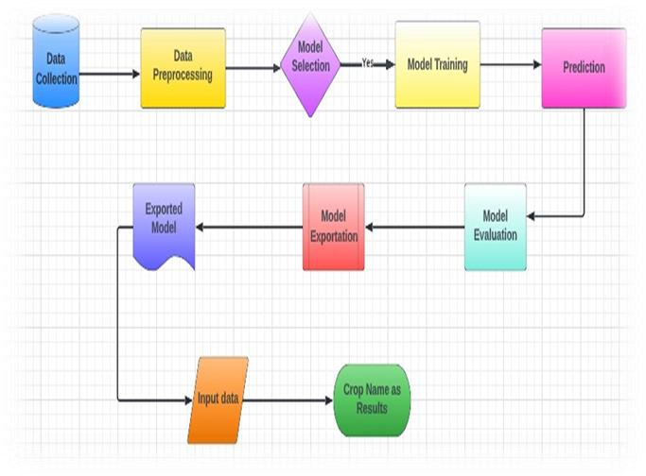

**Fig.1** Proposed Architecture Diagram The process includes:

Data collection: This involves gathering data on soil-related parameters, such as soil pH, nutrient content, and other relevant information.

Data preprocessing: The collected data is then processed and cleaned to ensure that it is accurate and suitable for analysis.

Model selection: Based on the characteristics of the problem and the data at hand, the best machine learning model is chosen.

Model training: The selected model is then trained using the preprocessed data to create a predictive model.

Prediction: After being trained, the model might be used to forecast the optimal crop based on the input data.

Model evaluation: The performance of the model is then evaluated to make sure that it is accurate and reliable.

Input data: The input data includes soil-related parameters and other relevant information that is used to generate recommendations.

Crop name as an outcome: Based on the input data, the system's final output is the suggested crop name.

Overall, this process utilizes machine learning algorithms to analyze soil-related parameters and generate personalized recommendations for suitable crops. Farmers can use the agronomic advisor application to determine what crops to grow in a particular environment.

**3.1 Dataset Collection**

The process of building a machine learning model begins with collecting data. It is important to collect data before constructing a machine learning model. It is crucial to obtain a sizable amount of reliable information that is pertinent to the issue at hand. Data collection allows us to keep track of past events, which allows us to use data analysis to find repeated patterns. This dataset covers characteristics specific to the soil. This primarily consists of the soil and agricultural dataset for India over the preceding 20 years. This information collection consists of over 2000 observations from over 20 distinct crops. In essence, crops rest on the ground. The soil's fertility is influenced by its texture and the presence of nutrients like nitrogen, phosphorus, and potassium. This information also includes historical weather patterns for India.

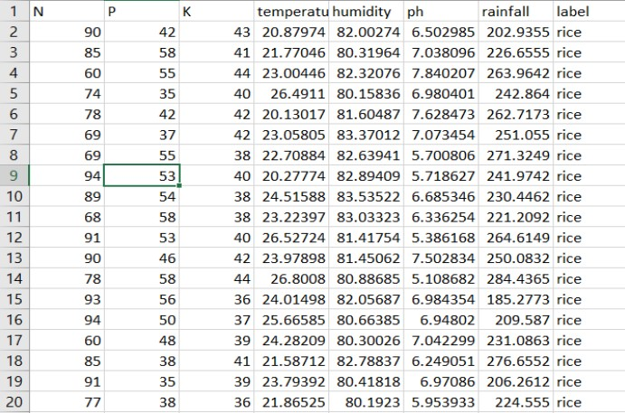

**3.2 Pre-processing**

Pre-processing entails taking away anomalies and disturbances from the CSV dataset. Data loss frequently occurs and has a direct impact on the final machine learning model's effectiveness and accuracy. This needs to be addressed using a variety of strategies, including median and overall column mean. We can quickly clean the dataset using skLearn. It offers an imputer class that addresses and replaces values when they are absent. The imputer class accepts arguments such as missing values and techniques the imputer employs internally. Using the mean on-axis, missing data are renewed using this method.

**3.3 Feature Selection**

To provide recommendations for suitable crops based on soil related parameters, the following features can be considered:

Nitrogen (N): Nitrogen is a essential nutrient that is vital for plant increase, and it performs a critical role in the improvement of plant life. The availability of nitrogen in the soil can influence the growth and yield of crops. Therefore, the nitrogen level in the soil can be a crucial feature for crop recommendation.

Phosphorus (P): Phosphorus is another crucial nutrient for plant growth and it is involved in various plant processes, such as photosynthesis, energy transfer, and root development. The availability of phosphorus in the soil can significantly impact crop growth and yield.

Potassium (K): Potassium is a vital nutrient that is involved in several plant processes, including water regulation, photosynthesis, and disease resistance. Therefore, the availability of potassium in the soil can be an important feature for crop recommendation.

Temperature: Temperature is critical environmental aspect which could impact crop growth and improvement. Different crops have different temperature requirements for optimal growth and yield. Therefore, temperature may be a critical feature in figuring out the most appropriate crop for a particular region.

Rainfall: Rainfall is some other critical environmental element which could impact crop growth and improvement.

Different crops have different water requirements, and the availability of rainfall can significantly influence the growth and yield of crops. Therefore, rainfall can be an essential feature for crop recommendation.

Soil pH: Soil pH can have a significant impact on plant growth and development. Different crops have different pH requirements, and the availability of soil nutrients can be influenced by the soil pH. Therefore, soil pH can be a crucial feature for crop recommendation.

Humidity: Humidity is every other crucial environmental aspect which could affect crop growth and development. . Different crops have different humidity requirements for optimal growth and yield. Therefore, humidity can be a critical feature in determining the most suitable crop for a

specific region.

To provide farmers with informed recommendations about what crops to grow based on their region's soil type and environmental conditions, the crop recommendation system takes into account various soil-related parameters as features. This allows farmers to make informed selections about the quality crops to develop.

**3.4 Choosing Machine Learning Model**

When choosing a machine learning algorithm, Random Forest is one of the most liked and widely accepted supervised learning techniques. It constitutes a number of decision trees for differential subsets of data, other than using the whole data as a single unit. This helps to enhance the accuracy of the prediction of each variable. It makes sense to use Random Forest on a large dataset as it can provide results with high accuracy in a minimum span of time. Random Forest, Decision Tree, Logistic Regression and SVM are used in this model.

**3.4.1 Decision Tree**

Decision trees are a type of tool that predicts outcomes based on characteristics. They use simple rules to make predictions

Decision trees can handle both numerical and nominal data.

The final prediction is made by gathering and combining all the results.

The Random Tree is a special type of decision tree that selects a random subset of characteristics to make predictions. The Random Tree builds multiple decision trees and combines their results for the best prediction

**3.4.2 Random Forest**

Random Forest helps to minimise overfitting in decision trees by introducing randomness in the tree construction process. The technique can handle missing data and still produce accurate results. The computational complexity of Random Forest is relatively low compared to other ensemble learning methods. Random Forest can be used for feature selection to identify the most important variables in a dataset.

The technique is insensitive to outliers and noisy data. Random Forest can be easily parallelized, Given that it is capable of handling datasets having continuous as well as categorical variables, the Random Forest is a flexible approach that may be utilized for a variety of applications. Random Forest often outperforms other machine learning algorithms when dealing with classification challenges.

The steps followed by the Random Forest algorithm are:

1. The original dataset is divided into n smaller bagged samples of size n.
2. A decision tree is constructed using input from all N bagged datasets. To calculate the ideal split, impurity measures such as Gini Impurity or Entropy are used, and M features are selected at random from the overall number of features in the training set to avoid looking at every feature in the dataset during a node split.
3. The unique outputs of each decision tree are combined into a single result.
4. For each observation, the outcomes produced by each tree are calculated, if working on a regression problem.
5. The majority vote is used to make a decision depending on the votes of the majority, if working on a classification problem.

**3.4.3 Support Vector Machine (SVM)**

SVM purpose is to identify a hyperplane in which the data points can be effectively separated (where N is the number of characteristics). In situations where there are two classes of data points, several hyperplanes can be utilized for classification. Data points are grouped into classes, and a hyperplane with the highest margin of difference is selected. By maximizing the margin distance, the accuracy of future data point classifications is enhanced.

**3.4.4 Logistic regression**

Observations are categorised into distinct classes using a method known as logistic regression. Examples of categorization problems include whether something is spam or not, whether an online transaction is fraudulent or not, and if a tumour is malignant or benign. The output of logistic regression is converted into a probability value via the logistic sigmoid function.

Which logistic regression models are there?

1. Binary
2. Failure of the class of multilinear functions, such as sheep, dogs, or cats.

An approach for predictive analysis is logistic regression, a machine learning technique that is used for classification issues and is based on the probability notion.

**3.5 Crop Prediction**

To determine the best crop variety for a particular region, the crop recommendation system employs a machine learning algorithm that takes into account the unique environmental factors of the area. The system utilizes user input data to train the model and identify the crop with the highest probability of success. To determine the ideal crop type, machine learning techniques including SVM, RF, logistic regression, and decision trees are used. The technology evaluates variables like humidity, soil moisture, temperature, and pH levels to suggest which crops farmers should produce.

**4 RESULT ANALYSIS**

The proposed crop recommendation model relies on a crop database and soil factors to suggest the best crop for a given soil type. The best crop variety is identified using machine learning algorithms, and the system found that the Random Forest technique generated the most accurate results. Table 1 shows the accuracy rates for each algorithm evaluated by the system.

**Table 1** Proposed methodology performance analysis

|  |  |
| --- | --- |
| Algorithm | Accuracy |
| Logistic Regression  Decision Tree  Random Forest  SVM | 95%  90%  99%  97% |

In this field, a number of prototypes have been put out that are helping to solve agricultural problems. Indian agriculture has enormous untapped potential. The technology that will help farmers by giving them the necessary advice on crops, their growth, and other fundamental information still has to be improved to be more compact, accurate, and affordable. The majority of the approaches now in use involve manually determining the soil type. The approach had a number of drawbacks. The system might not offer the necessary support in other circumstances. Therefore, this work suggested a novel strategy that is based on the location, to recommend crops and other strategy to address the drawbacks of existing papers.

**Table 2** Existing research papers performance analysis

|  |  |  |  |
| --- | --- | --- | --- |
| **Algorithm**  **Used** | **Accuracy** | **Drawback** | **Citation** |
| Subscription based system, ANN | 94.5% | Earlier-planted Crops unknown to the system. | [1] |
| Inference engine  ANN | 90% | Can Hadoop and Artificial Neural Networks work together to produce better results. | [2] |
| Recommendation generation module. | 92.4% | Crop growing season, crop output rate, and physiographic factors Database of seasonal crops. | [3] |
| Tools like CHAID, random tree, naive bayes KNN and  WEKA | 88% | Missing and out of range value. | [4] |
| Multiple Linear  Regression, SVM, Decision tree utilising ID3, K-means, C4.5, Neural Networks and KNN | MLR=  90%  NN=95% | For the algorithms to become more accurate, improvement is required. | [5] |
| J48, LAD tree,  LWL,  IBK algorithm | IBK gives the  highest accuracy | The LAD tree displayed the least accuracy. The tree can be pruned to reduce errors. | [6] |

**5. CONCLUSION**

The crop recommendation system has been effective in creating a model that can foretell which crops would do best given various environmental characteristics including topography, soil type, and climate. The system analyzes vast amounts of data to identify optimal crop varieties for different regions and soil types, considering factors such as temperature, rainfall, and soil fertility. After extensive research and analysis, the system has found that specific crops are better suited for particular regions and soil types. For example, crops that require high levels of rainfall are suitable for areas with high precipitation, while crops that can tolerate drought conditions are better suited for regions with low rainfall.

The predictive model developed by the system uses machine learning algorithms to analyze the data and provide customized recommendations to farmers. To recommend the best crops for a given region, the model consider a number of variables, including soil pH, nutrient content, and other environmental circumstances. By providing personalized recommendations, the system can help to increase crop yields, reduce costs, and improve efficiency in the agricultural sector. This, in turn, can contribute to sustainable agricultural practices and food security.

**6. REFERENCES**

1. Suruliandi, A., Mariammal, G., & Raja, S. P. (2021). Crop prediction based on soil and environmental characteristics using feature selection techniques. Mathematical and Computer Modelling of Dynamical Systems, 27(1), 117-140.

1. Doshi, Z., Nadkarni, S., Agrawal, R., & Shah, N. (2018, August). AgroConsultant: intelligent crop recommendation system using machine learning algorithms. In 2018 Fourth International Conference on Computing Communication Control and Automation (ICCUBEA) (pp. 1-6). IEEE.

1. S. P. Raja, B. Sawicka, Z. Stamenkovic and G. Mariammal, "Crop Prediction Based on Characteristics of the Agricultural Environment Using Various Feature Selection Techniques and Classifiers," in IEEE Access, vol. 10, pp. 23625-23641,

2022

1. Kulkarni, N. H., Srinivasan, G. N., Sagar, B. M., & Cauvery, N. K. (2018, December). Improving crop productivity through a crop recommendation system using ensembling technique. In 2018 3rd International Conference on Computational Systems and Information Technology for Sustainable Solutions (CSITSS) (pp. 114-119). IEEE.

1. Pudumalar, S., Ramanujam, E., Rajashree, R. H., Kavya, C., Kiruthika, T., & Nisha, J. (2017, January). Crop recommendation system for precision agriculture. In 2016 Eighth International Conference on Advanced Computing

(ICoAC) (pp. 32-36). IEEE.

1. Pande, S. M., Ramesh, P. K., Anmol, A., Aishwarya, B. R.,

Rohilla, K., & Shaurya, K. (2021, April). Crop Recommender System Using Machine Learning Approach. (Pp. 10661071),IEEE Xplore.

1. Liying Yang (2011), ‘Classifiers selection for ensemble learning based on accuracy and diversity’ Published by Elsevier Ltd. Selection and/or peer-review under responsibility of [CEIS].

1. Eswari, K. E., & Vinitha, L. (2018). Crop yield prediction in Tamil Nadu using Baysian network. International Journal of Intellectual Advancements and Research in Engineering Computations, 6(2), 1571-1576.

**Appendix – 2**

